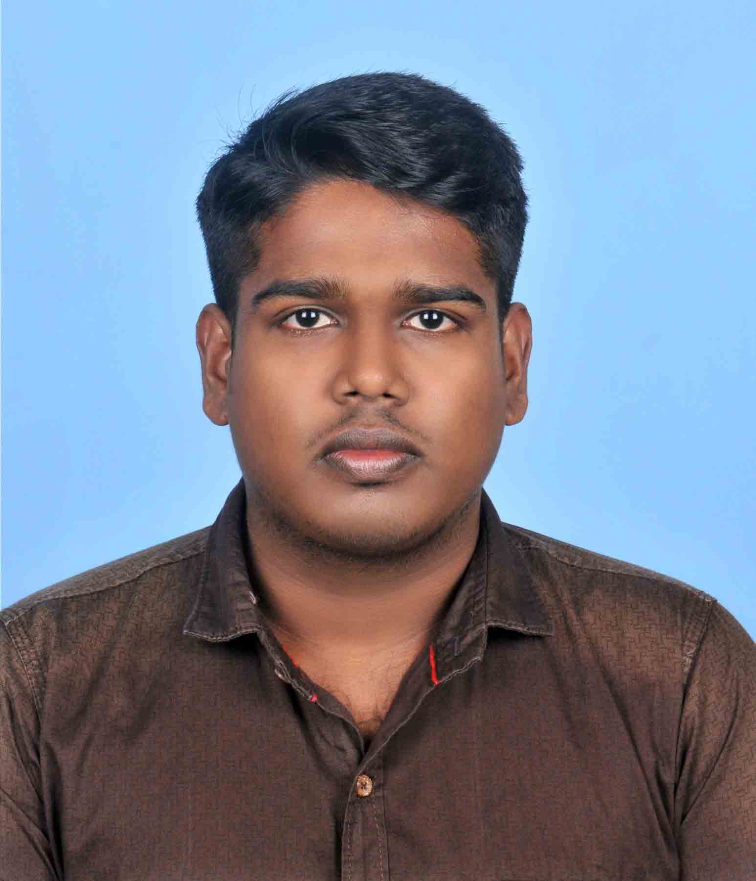
RESUME
ABIN N K
NADUVILKANDIYIL (H)
POOLENKARA
PANTHEERANKAVE (P.O)
CALICUT – 673 019
KERALA, INDIA

E-mail : abinnk1992@gmail.com
Contact No : 9388454647

CAREER OBJECTIVE:

Seeking a challenging position in a company that utilizes my potential to the fullest while offering an opportunity to further my career,
And thus contribute mutually to the benefit of the organization.

EDUCATIONAL QUALIFICATIONS:

COURSE | INSTITUTION | BOARD/UNIVERSITY | % OF MARKS
DOING M.COM | CMS COLLEGE CALICUT | BHARATHIYAR UNIVERSITY | Result awaited
B.COM | P S V M COLLEGE THALI | CALICUT UNIVERSITY | 54
PLUS TWO | MODEL HSS CALICUT | NCRT | 64
S S L C | PHS  PANTHEERANKAVU | SCRT | 75

EXPERIENCE:

- Two Year & One Month Experience as Accountant Assistant .
(@ Baiju Associates Tax Consultant, Mankave)
- Two Year & One Month Experience as Accountant.
(@ Sky Agencies, Pottammal)

- One Year Three Months Experience as Accountant.
(@ Four Leaves Turnkey Solutions P v t Ltd, Palazhi ) (Still Working)

LANGUAGES KNOWN:
  - English, Malayalam, Hindi

PERSONAL SKILLS:
- Ability to deal with people diplomatically, willingness to learn, team facilitator.
- Able to understand and carry out policies and procedures.
- Good centered behavior , patience and hardworking
- Can work under high pressure

HOBBIES:
- Watching Movies
- Listening Music
- Chess
PERSONAL PROFILE:

Sex : Male

Date of Birth : 25th June, 1992
Marital status : Single

Father’s Name : Sundaran

Mother’s Name : Geetha
Religion : Hindu
Caste : Thiyya

Nationality : Indian

DECLARATION:

I hereby declare that the above-mentioned information is correct up to my knowledge and I bear the responsibility for the correctness of the above-mentioned particulars.

ABIN N K

