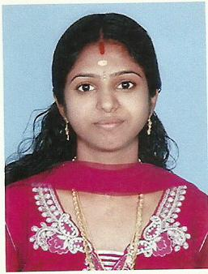 Anusree k

|  |  |
| --- | --- |
| Phone: 8086763578  Email: anuprayag2012@gmail.com |  |

.

# Education

**MBA** Information System Management in Bharathiar University 2015

**BSc** Information Technology in AJK College of Arts and Science 2011

**Plus Two** Board of Higher Secondary Kerala 2008

**SSLC** Board of Examination Kerala 2006

# Awards

Global Warming National Seminar 2008

# Experience

Tele Marketing Staff in First Source Solutions 2012

Office Assistant in Kerala Milk Federation 2014

Sales and Marketing Intern in IFORTIS World 2021

# Technical qualifications

* Tally
* Microsoft Office
* Microsoft Excel
* Programming Language - C,C++,VB
* Data Base - SQL
* Strong Knowledge on Internet

# Personal Profile

Date of Birth 23-01-1991

Gender Female

Nationality Indian

Marital Status Married

Passport No L5483564

# Languages

Malayalam - Native Language

English - Reading, Writing, Speaking

Tamil - Speaking

Hindi - Reading, Writing , Speaking

Sanskrit - Reading, Writing , Speaking

# Personal Information

Husband’s Name Sinosh

Father’s Name Kittumani

Mother’s Name Jyothi

Religion Hindu

Hobbies Reading

Books

**Declaration:**

I hereby declare that all the information stated above is true and sincere to my knowledge

**Place:** Palakkad ANUSREE K

**Date:**