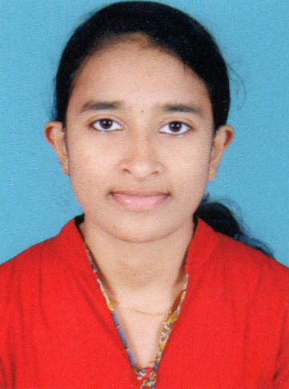
RESUME
ANJU BABU
KOLLIYELIL HOUSE
VENGOLA P O
MEPRATHUPADY
ERNAKULAM , 683556
Ph: 9645279293 , 9497719432
Email anjubabu0000@gmail.com

CAREER OBJECTIVES
To establish a career and to develop better quality of service in any job where I will Engage in and to further develop and enhance my potential and capabilities in a more challenging work atmosphere.

EDUCATIONAL QUALIFICATION

- S.S.L.C
- PLUS TWO
- BA ENGLISH WITH JOURNALISM
- MJMC

WORKING EXPERIENCE

*1 Months Internship in News 18 Kerala
* 1 Months Internship in Mathrubhumi Daily

PERSONAL INFORMATION

- Name : Anju Bbau
- Name of Father : K M Babu
- Religion : Christian- Jacobite
- Sex : Female
- Date of birth : 10-03-1998
- Nationality : Indian
- Marital status : Single
- Languages known : Malayalam,English, Hindi
- Extra Activities : Reading , Photoshop , Typit , Adobe Audition

DECLARATION

I hereby declare that all the above statements are true to the best of my knowledge and belief.
Place: Perumbavoor

Date: ANJU BABU

