Contact

**Address:**

Villa N.o 31, Behind Mushrif Mall, Airport Road, Abu Dhabi, UAE.

**Phone:**

+971552230153

**Email:**

[lakshmisg13@gmail.com](mailto:lakshmisg13@gmail.com)

**Visa Validity:**

15-01-2022

**Visa Type:**

Visit Visa

**Date of Birth:**

08-09-1997

Languages

English Upper Intermediate

Hindi Elementary

Malayalam Native

Education

* **MBA (HR & Marketing)**

**(**2018 – 2020)

UC College, Aluva, India

* **Bachelor of Business Administration**

(2015 -2018)

CET College, India

LAKSHMI GOPINATH

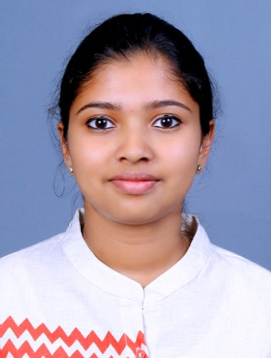

Summary

To obtain a position that will enable me to use my strong organizational skills, Educational background and ability to work well with people.

Skill Highlights

|  |  |
| --- | --- |
| * MS Word * MS Excel * MS Powerpoint | * Email * Social Media |

Experience

**Office Assistant** – February 2021 to September 2021

**Vector Surgical Disposables, India**

Administrative Works

* Maintaining Files
* Maintaining office equipment including scanners, printers, and telephones.
* Keeping an inventory of office supplies and ordering new materials as needed
* Preparation of Purchase Order & Proforma Invoice.

Customer Service

* Answering phone calls
* Taking customer orders
* Handling Inquiries
* Taking phone messages from clients
* Processing Transactions
* Handling amazon orders

Book Keeping

* Keeping track of receipts of office expenses or expenses incurred by managers or executives
* Creating invoices for customers

**Human Resource Intern** – January 2020 to February 2020

**V-Guard Industries Ltd, India**

* Schedule and confirm interviews with candidates
* Prepare Word, Excel and PowerPoint documents
* Sort incoming resumes and logs them into appropriate website
* Complete and mail out Interview call letters