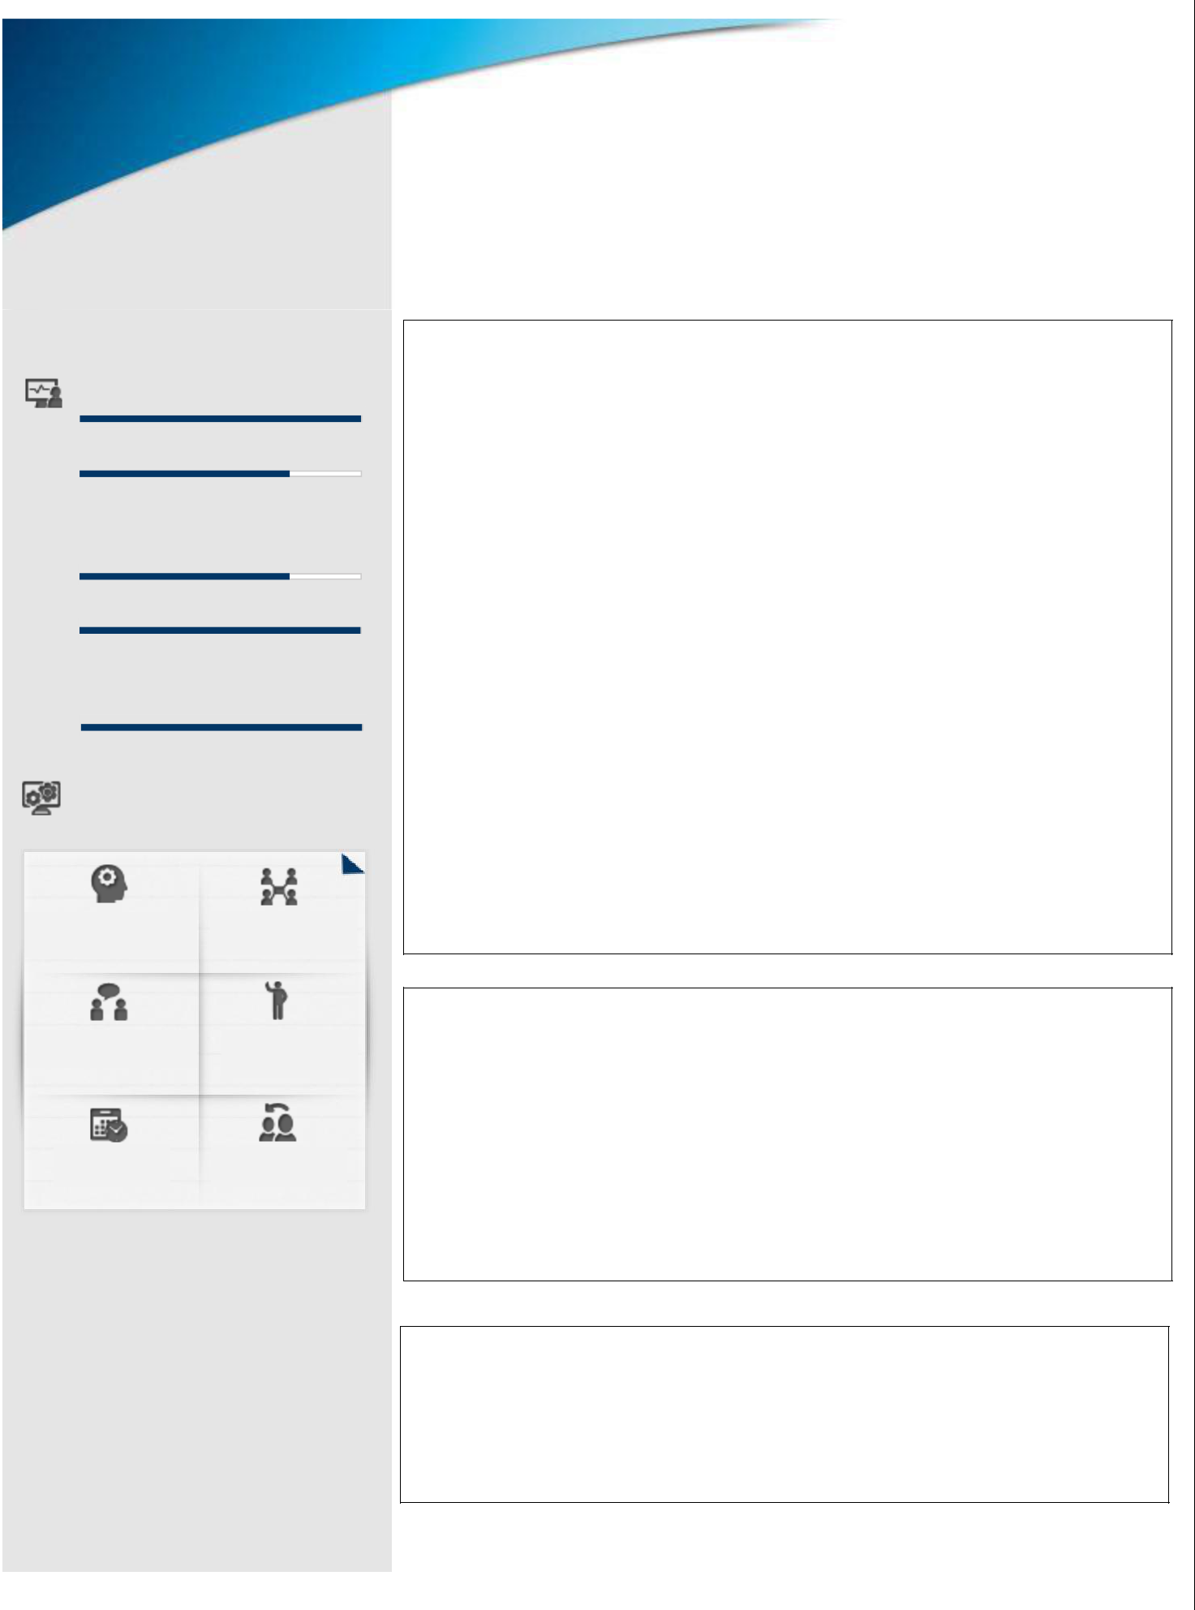

**Key Skills**

Front office Administration

Accounting and Tally

Commercially Aware

Self-Motivated

Guest Satisfaction

**Soft Skills**

**Influencer** **Collaborator**

**Communicator** **Motivator**

**Planner** **Emotional Intelligence**

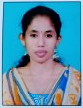 **SUKANYA K V**

Achievement-driven professional targeting challenging assignments in **HOSPITALITY MANAGEMENT**

[skv1673@gmail.com](mailto:skv1673@gmail.com)

+971 54 716 2227

Abu Dhabi (UAE)

**PROFILE SUMMARY**

* A result oriented hospitality professional with over 4+ years of experience in **Hotel Management Industry**.
* An energetic, talented and driven hotel management executive with a real passion for delivering a fast and good service to guests and maintaining excellent relationships with them to encourage repeat business. Having a proven track record of running successful operations that nurture and grow the business. Possessing the experience and initiative to further bolster a hotel’s reputation and commercial success.
* Looking to join a reputable and exciting hotel group where I can progress quickly and have the opportunity to develop an enviable career profile.

**EDUCATION**

* **Diploma in Hospitality Management** from Govt. Polytechnic College Attingal, Trivandrum during the period 2015-2018 with 90% marks.
* **COPA** (Computer Operator and Programming Assistant) from ITI Attingal during the period of 2014-2015 with 80% marks.
* **Higher Secondary** education from Govt. HSS Kummil during the period of 2012-2014 with 78% marks.
* **Secondary** Education from Govt. VHSS Kallara in 2012 with 80% marks

**WORK EXPERIENCE**

* Assistant to Accounts in **Indian Coffee House Restaurant Muroor (UAE)** (February 2020 – till now)



**WORK EXPERIENCE**

* Worked as F & B Hostessat **Somatheeram Ayurveda Group** during August 2018 to January 2020
* Worked as Front Office Assistant at **Travancore Heritage** at Trivandrum during July 2016 to July 2018

|  |  |  |
| --- | --- | --- |
|  | **PERSONAL DETAILS** |  |
|  | **Date of Birth** | **:**15–05-1997 |
|  | **Address** | **:** Sukanya Bhavan, Plankeezhu, Vattathamara P.O, KOLLAM-691536,KERALA, |
|  | **Nationality** | **:** Indian |
|  | **Marital Status** | **:** Unmarried |
|  | **Visa Status** | **:** Labour Visa |
|  | **Languages known** | **:** English, Malayalam |
|  | **Passport No** | **:** S9403890 |

**DECLARATION:**

I hereby declare that the details furnished above are true and correct to the best of my knowledge and belief.

Place: Abu Dhabi

Date: 31-08-2021 SUKANYA K.V