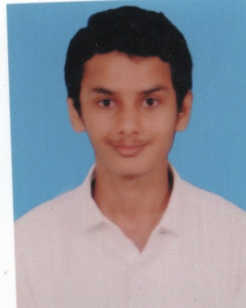 **CURRICULUM VITAE**

**Name: FARMANULLA Email:**farmanulla332000@gmail.com

**Address:** Achakka Compound,

Gandhinagar, Kavoor

Mangalore - 575015

**Mobile No**: 9632368852, 7204097217

### CAREER OBJECTIVE:

Seeking environment that will serve as a platform to learn and enhance my skills where in my knowledge and experience can be shared and enriched. To work in a progressive culture with the freedom to be creative, innovative and to grow along with the organization.

### EDUCATION:

|  |  |  |  |  |
| --- | --- | --- | --- | --- |
| **QUALIFICATION** | **STREAM** | **SCHOOL/COLLEGE** | **PERCENTAGE** | **YEAR OF PASSING** |
| DEGREE | B.COM | St. Aloysius Evening College | PURSING |  |
| KGTTI | CISCO,IT | KGTTI Kadrihills Mangalore | 92% | 2018 |
| ITI | Copa | Govt.ITIKadrihills  Mangalore | 59% | 2018 |
| PUC | Commerce | Mahatma Gandhi Centenary College,Bondel | 42.05% | 2017 |
| SSLC | State board | Mahatma Gandhi Centenary School,Bondel | 50.4% | 2015 |

### TECHNICAL SKILLS:

* Computer Skills: MS-Word, MS-Excel, MS-PowerPoint
* Tally ERP 9 Calculation Course
* CCTV Surveillance & Checking
* Data Entry typing

### EXPERIENCE:

* 1 Year Experience as Computer Operator and Programming Assistant Apprentice at the APD Secretariat Department,Airport Authority Of India,Mangaluru
* Experience of CCTV Camera Surveillance and Checking,Airport Authority Of India,Mangaluru

### TECHNICAL SKILLS:

* Software installation
* Computer Basics, Typing And Knowledge
* CISCO IT Technologies
* Internet & Multimedia
* Free lancer
* Presentation
* Typing and Editing

### STRENGTH:

* Punctuality
* Hard work
* Patience
* Good team player
* Good listener
* Good communication

### HOBBIES:

* Playing cricket, volleyball and football
* Reading and writing the knowledge and science article books
* Listening music

### PERSONAL DETAILS:

**Name**  **:**Farmanulla

**Father’s name :** Mohammed

**Mother’s name :** Saramma

**Date of Birth :** 03/03/2000

**Gender**  **:** Male

**Nationality** **:** Indian

**Languages known** **:** English, Hindi,Kannada

### Declaration:

I hereby declare that all statements made in this application are true and correct to the best of my knowledge and belief.

**Date: FARMANULLA**

**Place:Mangalore**