RENU SHARMA  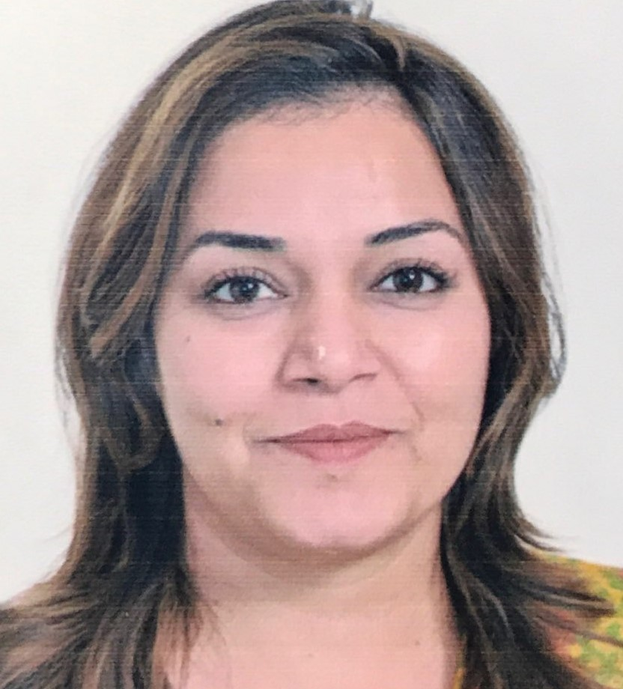  CONTACT  Address: Liwa Centre, Abu Dhabi, UAE  Phone: +971 526808917  Email: renusharmagemini@gmail.com  DOB: June 18, 1986 |  | ABOUT MYSELF  Highly motivated professional with over 10 years of experience in HNI business strategy & planning pan-India across distribution channels, Sales & Business Development, Client Relationships Management & Team Management for Insurance & Banking industry, Training facilitation, etc.  A keen planner, strategist & implementer with demonstrated abilities of multi-tasking & building and handling large teams.  Strong analytical, problem solving & organizational abilities with an aggressive go-getter attitude.  Outstanding success in networking across diverse strata with high levels of retention & loyalty.  WORK EXPERIENCE  June 2010 to Feb 2019  Associate Partner Sales  Max Life Insurance Co. Ltd.  Responsibilities  - Responsible for Sales Strategy for Agency Associate Channel.  - Recruiting & developing sales team of life insurance advisors.  - Leading a Team of 20-25 Financial Advisors operationally.  - Training teams in soft skills, man-management, rejection handling.  - Identifying Markets of HNI Ticket size for the company by means of Cross selling by Foreign National Business, CEIP, HUF, Business Insurance.  - Creating leads-referrals through sales campaigns & strategies & interfacing with HNI Clients.  - Networking with prospective clients and generating business from existing accounts for achieving profitability & sales growth.  - Managing a team of Agency Associates to deliver high standards of customer service and generating business out of them, thereby increasing the revenue of the organization.  - Relationship marketing with existing and new HNI clients.  - Supporting Recruitment of new advisors through Team of Agency Associates and motivate them through regular meetings, training program and on –the field support.  - Enabling Increased Recruitment Participation by means of Structured Training Modules and On Field Demonstration.  - Achieving Monthly targets of the company both in terms of Quality and quantity.  - Developing & sustaining high levels of post-sales professional services.  June 2009-2010  Relationship Manager  HSBC Bank  - Interfacing with HNI customers,  - Portfolio Management  - Investment Advisory  EDUCATION  2007 - 2008  - Post Graduate Diploma in Financial Planning from International College of Financial Planning and NSE qualified. Adept in:  - Risk management  - Financial Planning  - Derivatives  - AMFI  - Capital market  - Security Market  2004 - 2007  - Bachelors in Political Science (H) from Gargi College, Delhi University  ACHIEVEMENTS & ACCOLADES  Bagged 7 MDRT & 3 Council Centurion qualifiers in Max Life Insurance Co. Ltd.  Promoted twice from ADM to Sr ADM (2013) & Sr ADM to AP Sales (April 2017) in Max Life Insurance Co. Ltd.  REFERENCES  References available on request

