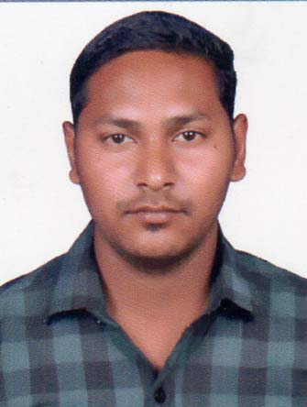
CURRICULUM VITAE s

KYATHAM MANOJ KUMAR ,
Email: kyathammanojkumar215@gmail.com
Contact: +971562227314
Career Objective:
Energetic and self motivated professional who takes a confident and creative approach to all duties and tasks has gained valuable experience within a reputable hotel chain and holds valuable experience. An enthusiastic team player that wishes to succeed in becoming part of a service oriented team within a major establishment within the hotel or catering industry.

Work Experience:

- Worked as a“Assistant Storekeeper” in United Families Catering Food Stuff Trading LLC at Abu Dhabi (2013-15)
- Worked as a “Office boy” in Abu Dhabi National Hotels at Abu Dhabi (2015-16).
- Worked as a “Assistant Storekeeper” in Sitara Hotel at Koti in Hyderabad, INDIA(2017)
- Worked as a “Office Assistant” in Vandhana Hire Purchase & Finance at Korutla
(20118-2019)
- Working in Spark Residency Hotel Apartments as a “Team Leader” at Sharjah May 2019 to till continue..

Education:

- SSC from Chetan Vidya Mandir in Kathalapur.
- Intermediate from Sri Vidyarthi Junior College.
- Graduation (B.Com) from Kakatiya University

Skills:
- Motivation to learn more about job responsibilities.
- Open to Feedback and Suggestions.
- Time Management Skills.
Technical Skills:
- DCA
- DTP
- Hardware & Networking

Passport Details:

- Passport No : J3447816
- Passport issue date : 18/02/2011
- Passport Expire : 17/02/2021

Profile:

Name : K. Manoj Kumar
Father’s Name : Rajesham
Date of Birth : 21/04/1992
Sex : Male
Marital Status : Married
Nationality : Indian
Language Known : English, Hindi, Telugu
Hobbies : Listening to Music, Playing Cricket.

Declaration:

I am confident of my ability to work in a team. I hereby declare that the information furnished above is true to the best of my knowledge. (K. Manoj Kumar)

