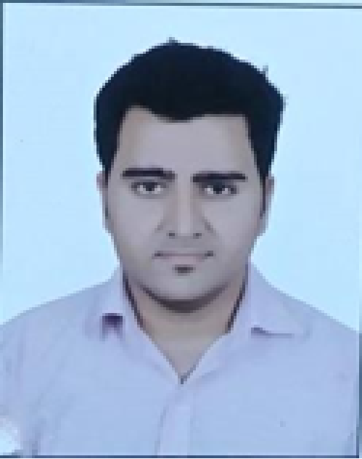 |  | Ayub  Sait
Profile  To establish myself, as a committed , hardworking and successful employee by learning and leading to achieve goals at a given period of time and to use my knowledge and skills ta tackle issues and gain success for organization and myself  _____________________________________  Persnal details  Date of birth: 2nd July, 1992  Nationality: Indian  Marital Status: Married  Contact  ADDRESS:  4/206,Ostwal Orchid Phase 1,Kanakia Society, Mira Road,Mum-400107  PHONE:  9821009859  EMAIL:  Ayubsait.frontmen@gmail.com  Hobbies  Strategic Mind Games  Team Sports  Creative hobbies  High-Risk pursuits |  | EDUCATION  N.M.F.C College  2012 - 2015  Science Major with Information Technology,  Major Subjects:- Physics, Chemistry, Biology, IT, Math  N.M.F.C College.  2009 - 2011  Bachelors of Information Technology.  Internship: TATA Interactive Services.  Courses:  CCNA, Cisco  May 2015 – Dec 2015  WORK EXPERIENCE  Cubezix Technologies [IT Support Specialist]  Oct 2019 – Aug 2020  Major job role was to do troubleshooting on clients' PCs via remote access and resolve it and if required then also use to visit the office for providing the fix. hardware such as PC, Network Printers setup, Voip Setup, NAS Installation, Server Raid Setup, Office to 360 Migration for customers and also if required exchange server outlook setup.  Tech Mahindra [Complaints Manager]  Aug 2018 – Mar 2019  Managing complaints of customers and providing resolution for their grievances with the brand by deriving excellent customer experience.  Managing case with Ombudsman (legal regulatory body for telecommunication in U.K) if there is any case filed against the company and providing related documents for the proceedings.  Super General Co LLC [Sales Officer]  May 2016 – April 2018  Managing sales for Hypermarkets such as LULU, Sharaf DG, EXTRA, etc. Marketing home appliances and categorizing types of home appliances and handling the inventory by coordinating with merchandisers, Maintaining excel sheets for quarterly sales and also cost for after sales services and providing flow charts in sales meet for the same.  Languages  English, Hindi, Marathi, Arabic (basic)  SKILLS  