***CURRICULUM VITAE***

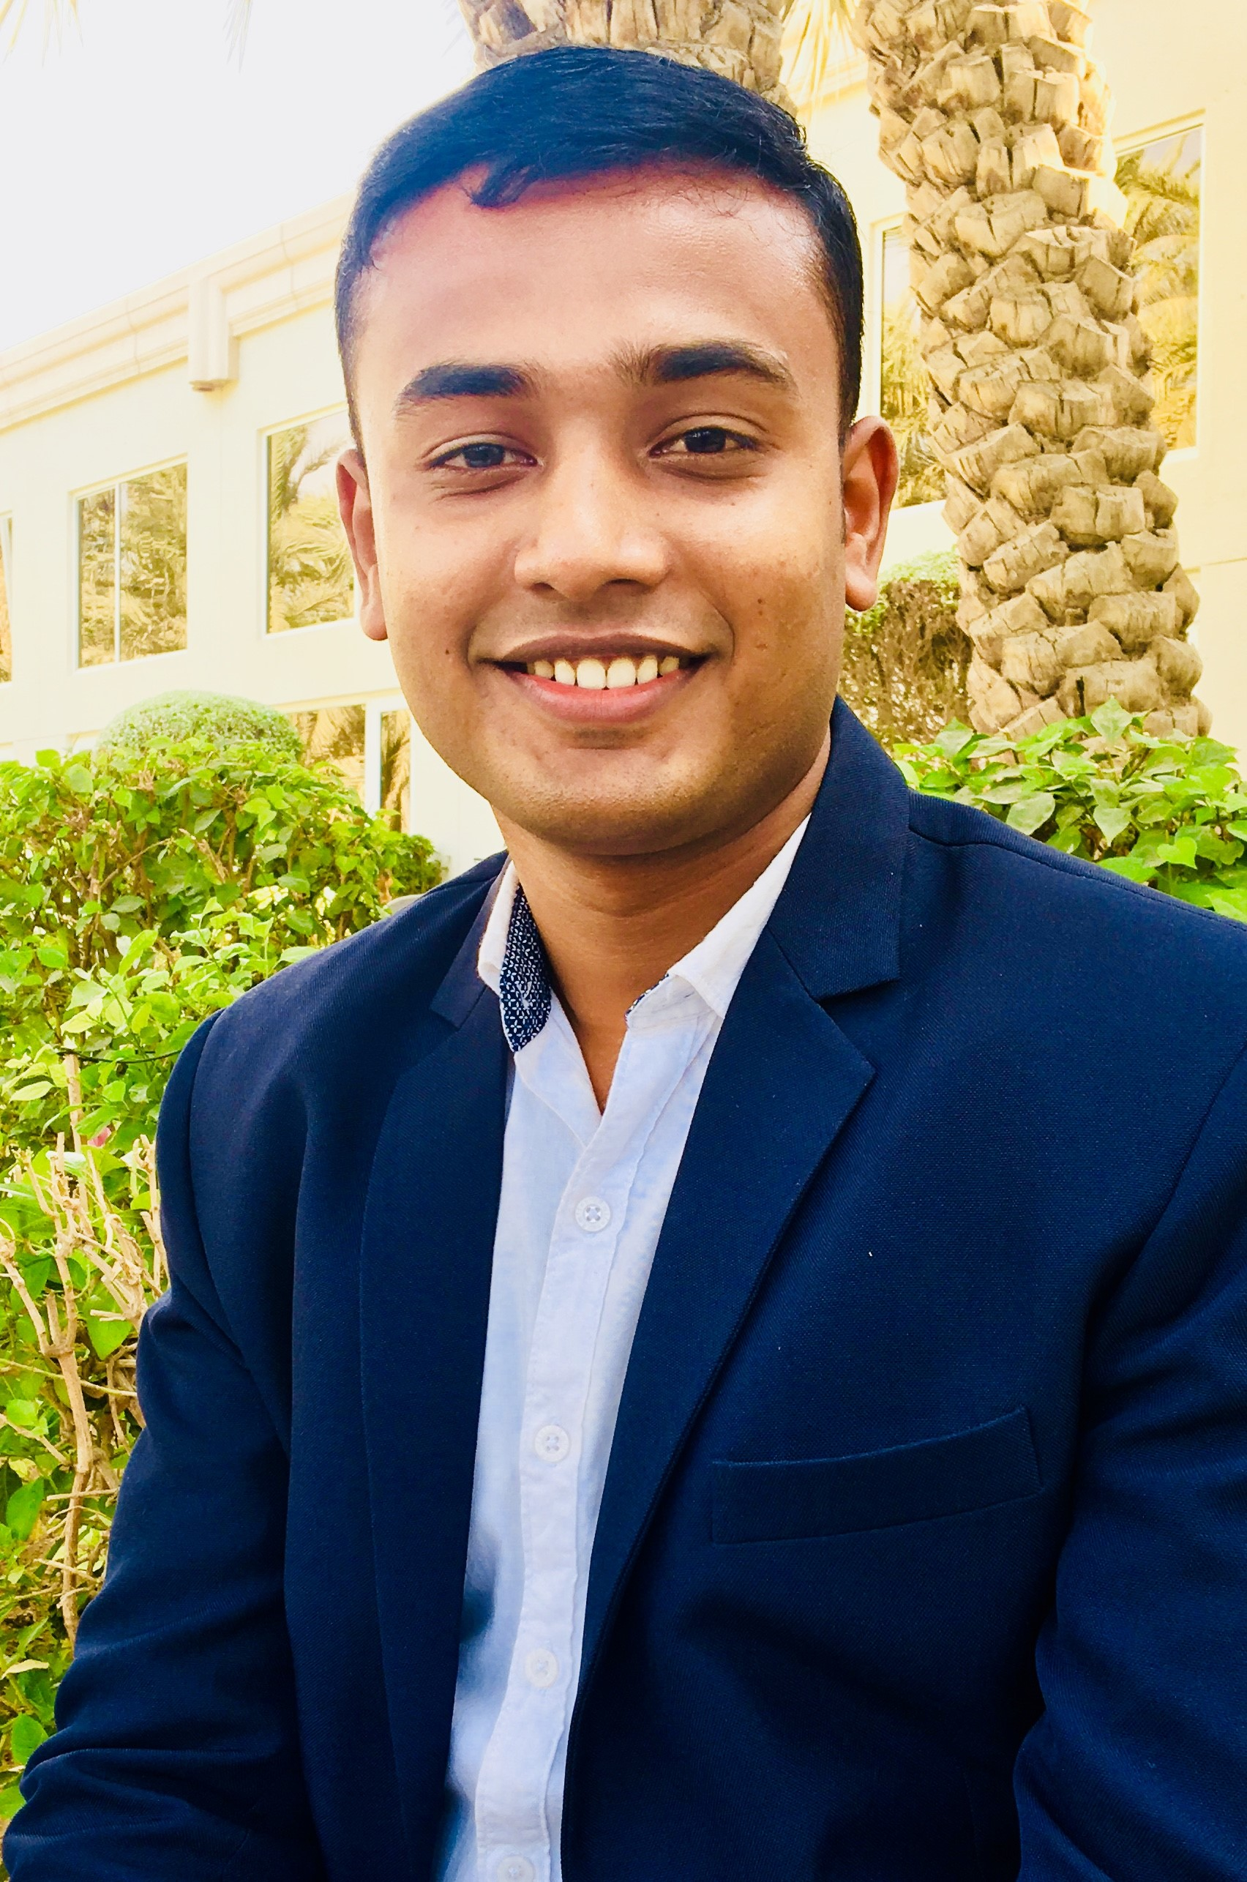

***JOICE THOMAS***

Email id:[joice7614@gmail.com](mailto:joice7614@gmail.com)

Contact: +919447997614

**Career objective:**

To work with an organization which gives me a platform to use my expertise and skills for the mutual growth and enhance my professional skills in the service industry.

**HIGHLIGHTS OF QUALIFICATIONS:**

• Functional knowledge of working in a restaurant environment  
• Highly skilled in mixing ingredients to prepare potent cocktails  
• Demonstrated ability to make guests feel well taken care of and build their intent to return  
• In depth knowledge of up selling items and serving beverages and food in accordance to state regulations  
• Thorough knowledge of the food, beverages and ingredients  
• Computer: MS Word and Excel  
• Bilingual: English and Hindi.

**SPECIAL EXPERTISE**  
• Setting and clearing tables  
• Welcoming and seating customers  
• Describing menu and drinks  
• Promoting local attractions  
• Taking and relaying orders  
• Serving food and drinks  
• Generating bills  
• Handling money

**WORK EXPERIENCE**

**Working as Sales Manager at Alnokhada Tourism LLC Dubai (March 2019-April2020)**

**Providing excellent customer support all types of travel/holiday requirements**

**Meeting with customers to finalize all the travel details for their trip**

**Contacting new potential customers and offering the services**

**Producing statistics on sales, travel destinations and customer satisfaction**

**Dealing with customer queries and issues on a regular basis**

**Ensuring that information is kept confidential and secure on databases**

**Working as Travel Consultant at New Horizon Travel & Tours Dubai (April 2017-Januvary 2019)**

**Arrange travel for business and vacation trips in Dubai**

**Arrange for tour packages, assisting guest, visa, flight tickets.**

**Collecting and processing the payments**

**Working as Senior Waiter at Movenpick Hotel Al Bidakuwait(December, 2014- March 2017)**

* **Allocating staff for duty as daily smooth operation.**
* **Maintaining logbooks.**
* **Monitoring bar stock for reducing shortage and overage.**
* **Monitoring and maintaining hygiene service.**
* **Always checking and maintaining mice-en-scene.**
* **Maintaining opening and closing checklist of the restaurant.**
* **Achieving daily task as per my managers log desire.**
* **Monitoring monthly budget and yearly budget.**
* **Maintaining guest history.**
* **Worked as a BARMAN RADHA REGENT ,CHENNAI (JUNE 2014 to NOV 2014)**  
  • Delivered outstanding dining experience  
  • Provided friendly and attentive service  
  • Ensure accuracy of order before serving

**KEY ACCOMPLIMENTS**  
• Managed food and beverage services for three parties simultaneously without compromising on quality of service  
• Named Employee of the Year following patrons’ feedback of excellence in customer services during the year 2015(Movenpick Hotel & Resorts Kuwait)

**Undergone Industrial Exposure Training Program in Hotel GREEN PARK, Chennai& RADISSON BLU CHENNAI (15 weeks),(2013)**

**EDUCATION**

* B.Sc. Hotel management in Madurai Kamaraj University, TamilNadu. (JULY2011-MAY2014)

**ADDITIONAL SKILLS**  
• Excellent customer orientation  
• willing to work a flexible schedule  
• Customer friendly demeanor  
• Superb communication and interpersonal skills and participated in cultural activities.

**PERSONAL INFORMATION**

Date of Birth - 11.09.1993

Nationality - Indian

Marital status - Single

Sex - Male

**DECLARATION**

**I do hereby declare that all the information furnished above is true to the best of my knowledge and I will deliver my best possible efforts to company’s satisfaction.**

Date: 21/06/20

Place: Kerala,Kollam JOICE THOMAS