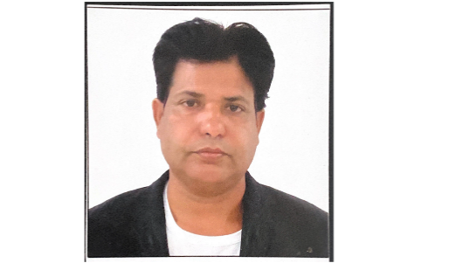**MOHAMMAD ABDUL KHABEER**

**MOB: +97150 6761823**

**P.Box : 22069**

**Email: Kbm2158@gmail.com**



**Covid-19 vaccinated**

# CAREER OBJECTIVES

To achieve high carrier growth through a continuous learning process and keep myself dynamic, visionary and competitive with the changing scenario of the world.

# EDUCATION QUALIFICATION

* Completed Hyderabad Secondary School, India with 68.64%

# ACHIVEMENTS

* Received appreciation from seniors
* Consistent Excellence in Quality
* Working hard

# STRENTH

Good Communication and Convincing Skills. 



Ability to Deliver under Pressure/Extreme Pressure. 

Good Logical and Analytical skills. 

Good Management Skills. 

Team player as well as Individual Contributor. 

Good Management Skills. 

# Working Experience

* Royal Travel & Tourism
* Princess Travel & Tourism
* Afridi Travel & Tourism
* German Travel & Tourism
* Lama Travel & Tourism
* Desert Rangers Travel & Tourism
* East Avenue Travel & Tourism

# DRIVING LICENCE DETAILS

License Number 538912

Date of issue: 24/10/2000

Date of Expire: 23/10/2025

Place of Issue: Dubai

Permitted Vehicle: 1/3 (Motor cycle / light vehicle)

# PERSONAL PROFILE

|  |  |  |
| --- | --- | --- |
|  |  |  |
| Name | : | Mohammad Abdul Kabeer |
| Date of Birth | : | 10-05-1967 |
| Nationality | : | Indian |
| Marital Status | : | Single |
| Languages Known | : | English, Hindi, Arabic and Telegue |
| Visa Status | : | Visa |

# PASSPORT DETAILS

|  |  |
| --- | --- |
|  |  |
| Passport No | : T6486415 |
| Place of Issue | : Hyderabad |
| Date of Issue | : 19/06/2019 |
| Date of Expiry | : 18/06/2029 |