*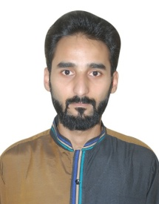AWAIS JAVAID*

*contact[1]*

*+*971583035894

House No F.2385 Moh Madni Taxila District

***Personal Information:***

## ***Father’s Name: Muhammad Javed Akhtar***

### ***Religion: Muslim***

***Nationality: Pakistani***

***Date of Birth: 10-11-1989***

***Marital Status: Married***

***Nic No 37406-3678438-1***

***Driving License LTV(Punjab)***

***Domicile*  *Punjab***

***Academic Record:***

|  |  |  |  |  |  |  |
| --- | --- | --- | --- | --- | --- | --- |
| ***Degree*** | ***Passing Year*** | ***Subject*** | ***Board/university*** | ***grade*** | ***Marks*** | ***Subject*** |
| ***Matric*** | ***2012*** | ***Science*** | ***Pindi Board*** | ***D*** | ***475/1100*** | ***Phy, Com,Che*** |

***skills :***

* ***01 Year DIT Diploma from HIT Taxila.***

***Objective:***

***Seeking a career oriented position in a challenging environment, providing opportunities for stability, growing and advancement, where I can utilize my academic qualification and related skills.***

***Experience:***

* ***03 Years Experience as a KPO (Key Punching Officer) in Bisconi Company.***
* ***02 Years Experience as a Data Entry Operator in Malik Enterprises.***
* ***02 Years Experience as (LDC) lower division clerk in HITheavy industry taxila.***

***Language:***

* ***Urdu***
* ***Punjabi***
* ***English***