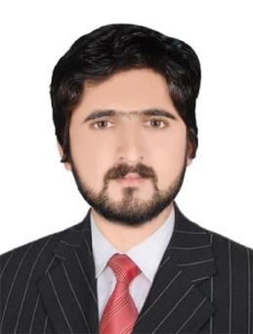**AMIR ZEB**   
Whatsapp : +971-521508959,

Email ID :**alchemistamirzeb@gmail.com**  
Mailing: **SHARJA, UNITED ARAB EMIRATES**

**Summary**

A technical person who has knowledge in operating computers and servers; has the ability to solve technical issues with utmost accuracy; excellent time management and analytic skills; can work under pressure; is able to work on abstract concepts and do technical analysis of systems.

**PERSONAL DATA:**

Date of Birth : October 10, 1998  
Sex : Male  
Marital Status : Single   
Nationality : Pakistani

CNIC :15605-0355293-9

Passport No : EK5092931

VISA STATUS : Visit Visa/ Tourist Visa  
Hobbies : Mountain Hiking, Reading, Photography

**Professional Experience:**

**Finance Manager and Database inCharge**

Brighto Paints Pakistan

Great Experience and learning during this period with Brighto Paints. Brighto Paints is a Multi-National Company in Pakistan.

Pak institute of technical education, PAK19110

**Computer Instructor**

PAK Institute of Technical Education

Responsible instructor and also good student in Pak Institute of Technical Education. Pak institute of technical education one of the best training center in our city.

**Sale Manger**

Zara Collection Point

I’m also responsible in Zara Collection Point for Hiring, Training, Motivating, and Directing the Sale personal who attend Costumer.

**Responsibilities:**

* Organized schedules in the daily operations of maintenance in computer systems.
* Assisted in verifying computer reports before releasing it to the operations supervisor.
* Reported all hardware and software problems to the operations supervisor in order to solve the issues at once.
* Maintained records of all maintenance conducted.
* Conducted follow-up actions on all customer queries to ensure improvements in customer service.
* Assisted in the recovery activities during failures to restore normal operations.
* Ensured that all computer servers are all in proper working conditions.

**Education & Training**

* Bachelor of Science (Honor) University of swat, Pakistan.
* Diploma in Information Technology KP, Pakistan, Trade Testing Board Peshawar.
* Computer Keyboard Training , Khyber Computer and Vocational College.
* Financial Accounting, Skill Development Council.

**Skills:**

* Excellent in logic and detail skills
* Ability to perform analytical work
* Excellent in communications and written skills
* Proficient in computer codes language
* Proficient in using the operating systems

**References:**

**Wajid Ali (Principal)**

Pak institute of technical education

Khwaza khela Swat, KP, Pakistan