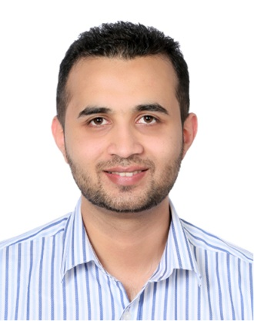
AHMED ALI MAQBOOL

Marketing Specialist

PROFESSIONAL PROFILE
A Highly Capable as experienced Marketing Specialist. Capable of managing projects in any sized business. He loves to bring in a project on time, within budget and to very high standard. He is more than capable of taking any idea from conception to completion.

CONTACT:
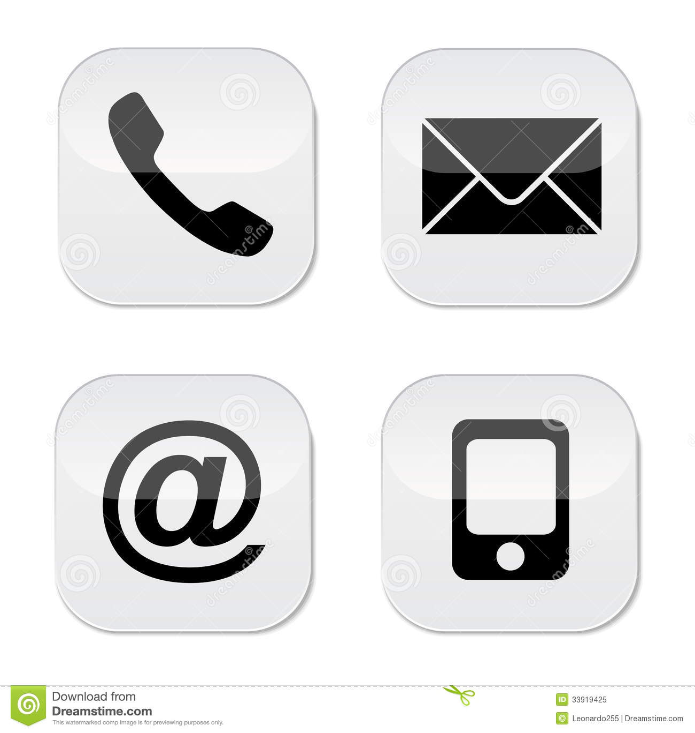 Mobile +9715 0512 3001
 Email:Ahmedalimaqbool@gmail.com
 Address: Dubai, UAE
 linkendin.com/ahmed-maqbool

PERSONAL DATA:

Nationality: Pakistani

Language: Urdu, English (fluent)

Age: 34

UAE Driving Licence

CAREER/WORK EXPERIENCE

2020-Till Date
FIRE SHIELD INDUSTRIES LLC.
Marketing Specialist

- Analyse market data local & national.
- Market the products and determine the products required in market.
- Working as part of the sales team to develop both new and existing markets.
- Meeting with Consultants, Client & Contractors for introducing the products.
- Company Introduction in order to be in vendor lists.
- Managing SEO .

2019-2020
Al Khaleej Metal Coat LLC. (Juma Al Majid)
Senior Marketing & Sales Executive

- Responsible for selling (Steel door & Rolling Shutter), closing, servicing and
Expanding the current customer base within an assigned territory (GCC).
Supervise a team of 4 people.
- Manage, develop, coach, control and motivate the sales force to develop their skill to ensure that a high professional standard is achieved and monthly sales target and KPI target are met.
- Assess the strengths and weaknesses of the sales team and manage the sales program accordingly

2016-2018
BIN GHURAIR TRADING LLC. (A&H INVESTMENTS)
MARKETING & SALES EXECUTIVE

- Working as part of the sales team to develop both new and existing markets.
- Meeting with Consultants, Client & Contractors for introducing the products.
- Liaising with customers to answer and resolve their queries.
- Identifying and then researching potential leads and opportunities.
- Maintained close client communications while clearly defining marketing objectives.
- Cold calling potential clients via telephone or personal visit.



ACADEMIC ACHIEVEMENTS

ANGLIA RUSKIN UNIVERSITY UK 2011-2013
MS in Marketing & Innovation

SARHAD UNIVERISTY OF SCIENCE & TECHNOLOGY 2008-2010
Masters in Business Administration (Human Resource Management)

SARHAD UNIVERISTY OF SCIENCE & TECHNOLOGY 2004 -2007
Bachelors in Business Administration

REFERENCES
Available on request.

STRENGTH

- Ambitious and highly motivated to meet the demands of the job
- Excellent skills in marketing and business development
- Experienced in merchandising and managing sales in various retail outlets and international brands
- Have a track record of getting results and generating sales and improve the service offered
- Able to identify and develop new business opportunities
- Exceptional communication skills
- Good time management skills
- Able to work under pressure and with no supervision at all
- Skilled in various computer programs in sales and marketing
- Previous experience working in competitive markets and delivering results
- Great troubleshooting and problem-solving skills

