RESUME
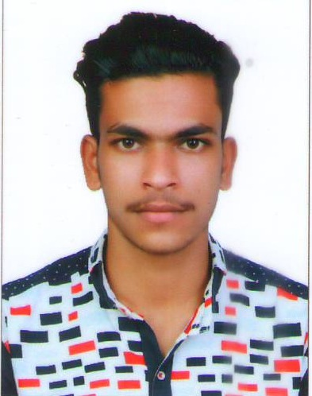

ABDUL SHUKOOR C K
Hidayath Villa
Chembarika, Kalanad
Kasaragod, Kerala -671317
Whatsapp No: +919645245145
Uae No: 0567363309
Enail: farzanashukoor18@gmail.com

Career Objective

To be a part of company that can provide a more challenging and rewarding career that could sharpen and enhancing my skill and knowledge and allow professional advancement and fulfillment.
Personal Profile

Date of Birth : 14/04/1997
Gender : Male
Father Name : Kunhimahinkutty
Religion : Muslim
Native Place : Kerala
Languages Known : English & Malayalam
Marital Status : Single
Nationality : Indian
Educational Qualification

- SSLC- Board Of Kerala
- PLUS TWO – Board of Kerala
Work Experience

- 1 Year Experience as DELIVERY Boy at Madani Enterprises Kasaragod.
- 1 Year Experience as MUBAZARAH TECHNICAL @ dubai fire and safety work
- 6 Monts Experience as AL MADEENA SUPER MARKET In dubai
- 5 Months Experience as Fajar jewellery China mall In Dubai
DECLARATION

I hereby declare that all the information given above is my own and true to the best of my knowledge and belief.

Place: Kasaragod ABDUL SHUKOOR C K

