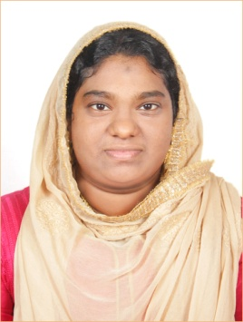

**SHANIBA SINAR**

Mob.no : +91 9567043681

Shanibasinar100@gmail.com

-------------------------------------------------------------------------------------------------------------

**Career Statement:**

Aim to be an associate with a progressive organization that gives me scope to update my knowledge and skills in accordance with the latest trends and be part of a team that dynamically works towards growth of organization

------------------------------------------------------------------------------------------------------------

Working Experience:

I have 2 year experience in Documentation, Reception and Recruiting.

**Educational Qualifications:**

* **B.Sc (MATHEMATICS) 83% from, THE COCHIN COLLEGE, KOCHI-2**
* **H.S.E. with 82% from Govt. HSS central calvathy, Kochi, Kerala**
* **S.S.L.C with 83% from Fathima Girls High School, Kochi, Kerala**

-------------------------------------------------------------------------------------------------------------

**Computer skills:**

* Certificate course in Visual Basics
* Working experience in Word, Excel, Browsing Etc.

----------------------------------------------------------------------------------------------------------

**Hobbies:**

* Drawing
* cooking

-------------------------------------------------------------------------------------------------------------

**Strengths:**

* Hardworking
* Punctuality
* Positive attitude

**Personal Details**

Age & Date of Birth: 29yrs 05-02-1991

Address : 1-1989, YMCA ROAD, Fortcochin-1

Contact No : +91 9567043681

Alternative No : +91 9895948561

Sex: Female

Marital status: Married

Husband Name : P.Mohammed Sinar

No of Kids : 02

Languages known: Malayalam and English(Beginner)

-------------------------------------------------------------------------------------------------------------

# Declaration

The details given above are true to the best of my knowledge and belief.

PLACE: COCHIN SHANIBA SINAR