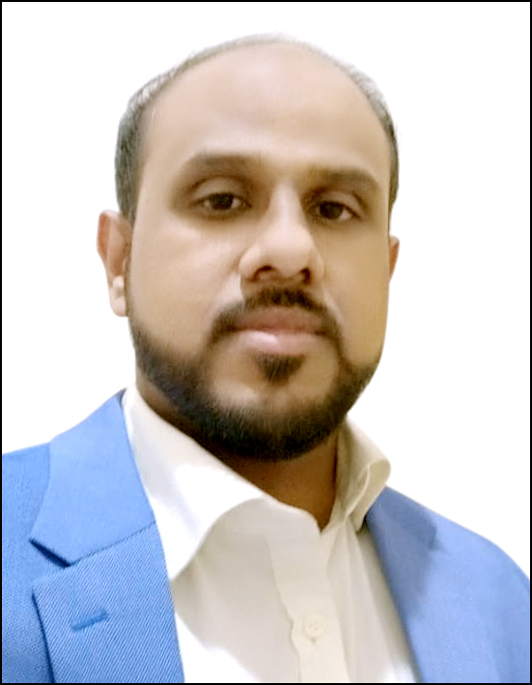
NIYAZ AHAMED
Mobile: +971508363357 / E-Mail: aniyazahmed@yahoo.co.in / LinkedIn: aniyazahmed / Valid UAE Driving License
SENIOR LEVEL SALES/ CUSTOMER SERVICE & MARKETING PROFESSIONAL
Sales & Marketing ~ Business Development
Industry Preference: Banking & Financial Sector.

An accomplished professional with a dynamic career in Sales & Marketing, Customer Service, Retail Banking Operations, Business Development, Client Servicing & Brand Management in Banking Industry across multiple categories, leading high growth and new brand launches

Acknowledged for strengthening companies to lead in highly competitive markets and delivering innovative marketing concepts & strategies

PROFILE SUMMARY

- An accomplished & result oriented professional with 16 years of experience in the arena of:
Sales & Marketing Retail Banking Operations Business Development
Client Relationship Management Account Development Region & Territory Expansion
Brand Management & Product Promotion Channel Management Team Leadership

- Wide-ranging knowledge of Retail Banking industry & its procedures as well as the ability to think smart & act fast
- Recognized for contributions to record setting sales figures, territory start-up/expansion & new account development
- Concurrently ensuring overall pipeline & revenue growth within channel and territory; engaging channels to close sales & deliver services, thereby providing ongoing support & training
- Adept at developing relationships with key decision-makers/channel partners in order to achieve business targets
- Deft in identifying and implementing strategies for building team effectiveness by promoting a spirit of cooperation between team members
- Possess sound planning and people management skills

CORE COMPETENCIES
Sales & Marketing
- Forecasting monthly / annual sales targets & driving sales initiatives to achieve business goals and managing the team to achieve them
- Analyzing latest marketing trends & tracking competitors’ activities and providing valuable inputs for fine tuning of sales & marketing strategies

Retail Banking Operations
- Handling & monitoring the Retail Banking Operations as per priority; managing & checking daily reports for all the retail assets transactional banking of the branch
- Conducting system study to increase sale on the basis of different rations used in accounting & mapping business requirements for process enhancements and translating these requirements into functional specifications

Business Development
- Exploring business potential & opportunities and expanding client base to enhance business volumes
- Developing alliances & relationships with business partners by identifying the strength of each partner and coordinating with them for effective business development

Region & Territory Expansion
- Gathering feedback from the territory and handling sales & marketing function of new products & services according to results
- Developing relationships with HNI clients to expand territory growth

WORK HISTORY

Since Aug'17 with RAK Bank, Dubai, UAE as Customer Services and Sales Officer (Retail Distribution)

Key Result Areas
- Carries out all branch tasks ensuring all activities are completed with timescales and with a high degree of accuracy, whilst providing excellent customer service, to both external and internal customers, and adhering to appropriate process and procedures.
- To manage the customer service functions of the branch by ensuring delivery of quality service to customers and meeting sales targets, while adhering to service standards and maintaining of operational controls.
- Promoting and selling financial products to meet assigned sales targets.
- Effectively used applications Finacle, CRM, Finone CAS, RLS Collections, Intellect Collections in branch operations.
- Ensure A/c opening docs, KYC, FATCA, CRS self certification forms are duly filled and are scanned via Omniflow.
- Ensure that no unapproved CIF / SR / SRB lying pending in system, if they are then action has to be taken as outlined in the OP.
- Provides specialist information, guidance and advice to customers through the delivery of excellent customer service to resolve customer queries and achieve customer satisfaction at all times to ensure positive image of the bank.
- Develops and maintains new and existing relationships with other departments/customers to support the achievement of business objectives.
- Perform any other duties or tasks as required or instructed by the line manager to support the smooth operation of the branch.

Accomplishments:
- Successfully handled the branch in terms of Customer service and constantly achieving set Targets.

Oct’15 – Mar'17 with FGB Bank, Dubai, UAE as Personal Banking Advisor (Retail Banking)

Key Result Areas
- Responsible for marketing the Retail Bank's products and services to meet assigned targets, besides cross selling other products and services of the Retail Bank to meet customer needs.
- Meeting targets in multi products. (Loans, Cards, Mortgage, Investments, Insurance).
- Meeting customer expectations in terms of efficiency, accuracy, timeliness and professionalism of response either face to face, in written or at the telephone.
- Achieve cross sale penetration rates and wealth referrals achieved for account opening, lending and other sales.
- To work as part of an integrated branch management team to ensure, standards and are met and operating models delivered.
- Ability to identify customer needs and influence customers to take appropriate action to meet their needs.

Accomplishments:
- Successfully handled the companies like Emirates Logistics, Kingston Management Holdings.

Mar’14 – Aug’15 with Mashreq Bank, Abu Dhabi, UAE as Sales & Service Officer (Retail Banking)

Key Result Areas
- Providing financial services to the customers which exceed customer's expectations by delivering unbiased, competent, timely and problem free service.
- Be imaginative and creative in the delivery of customer service and Ensuring customer retention.
- Improving service levels at the branches and taking ownership of customer complaint resolution.
- Team player, contributing to achievement of goals based on Key Performance Indicators in the branch.
- Providing constructive & constant feedback on improvement of products, services & processes which may either reduce cycle time or costs or enhance customer satisfaction.
- Ensuring customer acquisition through sales to walk-ins and through tracking the activities.
- Meeting with the set service standards (Indicators & Surveys).

Accomplishments:
- Successfully done campaign & promotional events in the companies.
- Handled key clients like I mass Investments for retail business.

Oct’07 – Feb’14 with Emirates NBD, Abu Dhabi, UAE as Senior Sales Supervisor (I.B.S. Department)

Key Result Areas:
- Motivating the team members to achieve their targets, heading a team of 6-7 members.
- Ensuring the promotion of business by visiting companies, meeting clients to educate them about the product & converting them to profitable business.
- Responsible for sales and marketing of personal loans, credit cards, accounts and investments.
- Ensuring the sales growth by different ways involving, Identifying companies with high revenues & high profile clients.
- providing excellent service & maintaining the chain of customers & getting references from them.
- Maintaining tie-ups with company’s Finances & HR Departments to facilitate the employees with the best banking products and generate huge business revenue.

Accomplishments:
- Successfully handled key clients like Emal, GMS, Environment Agency, MOI, etc.
- Acknowledged as 2nd Runner Up for 3rd Quarter in 2009 and 2nd Runner Up for overall achievement in 2011.
- Involved in selling high & asset profitable products at competitive & profitable rates to bring the company profits.
- Attended Tea with CEO for being a top performer in 2013.

Dec’05 – Aug’07 with National Bank of Dubai, Abu Dhabi, UAE as Sales Executive

Key Result Areas:
- Identified business opportunities and mapped requirements through marketing research.
- Involved in arranging database from different companies or business.
- Worked towards achieving assigned targets through primary & secondary sales.
- Responsible for administering sales & marketing operations and driving initiatives in order to increase revenue volume and achieve business goals.
- Mapped client’s requirements, identified areas of improvement and implemented measures to maximize customer satisfaction levels.

Accomplishments:
- Successfully completed cards target through direct marketing, tele-calling and references selling
- Proactively developed leads and database for achieving the business targets

Nov’03 – Nov’05 with ICICI Bank Ltd., Chennai as Sales Officer / Executive

Accomplishments:
- Proactively organized & implemented promotional activities viz., Loan Melas
- Successfully handled 4 branches and attended customer queries and issues regarding car loans
- Introduced product promotion in residential areas through direct mailers, banners, broachers, paper insertions, etc.

Jun’03 – Oct’03 with Airtel Connect, Chennai as Sales Executive

Accomplishments:
Headed sales initiatives and accomplished desired targets through cold calling & direct sales
- Significantly expanded market reach in the sales territory with greater brand awareness & growth in sales of the respective brand.

EDUCATION
Pursuing MBA (Banking & Financial Services Management) from IIBM Institute of Business Management, Meerut, India.
2003 B.Sc. (Computer Science) from New Prince Shri Bhavani Arts & Science, Chennai.

PERSONAL DETAILS
Date of Birth: 8th March, 1983
Language Skills: English, Hindi, Tamil & Malayalam
Nationality: Indian
Marital Status: Married
Passport Details: L4982463, 27/11/2023

