**Analou Tiborio Verin**

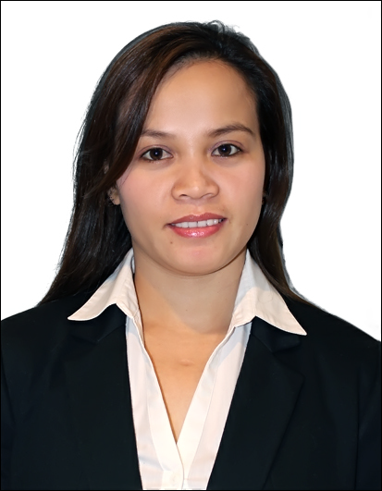

**Mobile No**. + 971501094885

verianne12684@gmail.com

**OBJECTIVE**

A motivated individual looking forward to utilize my experience and education to its full potential and

to be a key asset in the growth of the organization and self through excellence and dedication.

**PERSONALITY**

* An experienced, highly motivated and flexible individual
* Punctual and dedicated to the job, fast learner, hard working and responsible
* Takes Initiative and resourceful, maintains and observes honesty and loyalty
* Customer service oriented
* Can work under minimum supervision
* Have strong personality, determination and patience

**POSITION DESIRED: CUSTOMER SERVICE OFFICER/ RECEPTIONIST/ADMIN ASSISTANT**

**CAREER HIGHLIGHTS**

**Customer Service**

**G4S Company**

**Abu Dhabi/Dubai International Airport**

**June 2012 – 30 Mar 2020**

* Warmly greet guests as they approach with a smile and guide them to the respective check in counters/ boarding gates making a positive impression that the guest will remember.
* Effectively handling the queuing process at the X-Ray screening area with due consideration given to elderly guests and guests with children and special needs.
* Assist deplaning guests with questions/enquiry about their connecting flights and guiding them to their respective gates and directing other guests who are entering the country through Immigration process and baggage reclaim area.
* Escorting guests with special needs and requirements such as disabled, the elderly and unaccompanied children, sick guests to and from the aircraft with care and empathy.
* Respond to guests concerns, suggestions and complaints in a timely, professional and consistent manner
* Manning the Information desk and effectively anticipating the customers’ needs, giving them accurate information and guiding them with compassion and care making every customer’s journey a satisfying one. Attend all meetings and training sessions as required
* Adhere to policies and procedures of the company
* Adhere to safety policies and procedures
* Constantly improving the ability to serve others with effective customer service which involves solving customers’ problems and earning their trust with the aim of increasing their loyalty to our business.

**Receptionist**

**ACS Manufacturing Corporation**

**Tacloban City**

**Philippines**

**January 2010 – May 2012**

* Warmly greet members and guests as they approach in the reception area
*  Use customer’s and guest’s names whenever possible.
* Professionally verify Identity cards.
* Respond to members’ concerns, suggestions and complaints in a timely,
* professional and consistent manner
* To manage the reception area on a day to day basis
*  To answer the telephone calls promptly and in a polite manner
* Explain products or services and prices, and answer questions from customers.
* Obtain customer information such as name, address etc.
* To take messages for visits and advice
* Record names, addresses, purchases, and reactions of prospective contacts.
* Attend all meetings and training sessions as required
*  Adhere to policies and procedures of the company and Reception department
* Adhere to safety policies and procedures.
* To undertake typing and photocopying duties as and when required
* To assist in any administrative task as required
*  Review communication Book at the beginning of each shift.
* Maintain excellent communication channel between customers and staff.

**Sales Assistant**

**Novo Department Store**

**Tacloban City**

**Phillipines**

**October 2007 – December 2009**

* Welcome the customers in the store and greet them with a smile.
* Ensure that the products in the store are well organized as per their category
*  Assist customers to find what they need
* Advise customers to choose the best product
* Handle payments for the goods purchased
* Attend calls for customers availing home delivery facilities
* Keep a neat record of cash, and different receipts, and bills
* Making arrangements for the customers needing a refund, or replacement of their products
* Order products running out of stock, and then receive deliveries
* Being up to date with the latest promotional schemes on various products, and informing customers about the same
* Attending team meeting and sharing best practice with colleagues

**Admin Assistant**

**SM City**

**Manila**

**Philippines**

**December 2004 – August 2007**

* Sort and distribute incoming mail to areas and staff within the organization and dispatch outgoing mail
* Write business letters, reports or office memoranda using word processing programmes
* Answer telephone enquiries from customers, attend to visitors and assist other staff in the organisation with their enquiries
* Operate a range of office machines such as photocopiers, computers and faxes
* File papers and documents
* Prepare and modify documents including correspondence, reports, drafts, memos, and emails
* Keep a neat record of cash, and different receipts, and bills
* Making arrangements for the customers needing a refund, or replacement of their products
* Order products running out of stock, and then receive deliveries
* Being up to date with the latest promotional schemes on various products, and informing customers about the same
* Maintain office supplies for department
* Undertake other duties as assigned
* Attending team meeting and sharing best practice with colleagues

**ACADEMIC QUALIFICATION**

2002 – 2004 Computer Secretarial Course

Leyte Institute of Technology

Tacloban

Philippines

1997 – 2001 High School

Simeon Ocdol National High School,

Basey,

Samar Leyte

Philippines

**COURSES ATTENDED**

* Service Flair Programme – 02nd August 2016 (Dubai Airports)
* Aviation 102 – 11th & 12th November 2015 (Dubai Airports)
* Service Boot Camp – 08th & 09th March 2015 (Dubai Airports)
* Graphic Design – Batch 14 – 08th April to 03rd June 2011 (PISCO Pvt. School AD)
* International Computer Driving License (ICDL) Batch 7 –17th Dec 2010 to 25th Feb 2011
* International Computer Driving License (ICDL) Batch 12 – 08th Oct to 19th Nov 2010

**AWARDS**

Employee of the Month – May 2013 (G4S Facility Services)

**ADDITIONAL SKILLS**

Proficient in Microsoft Office applications

Knowledgeable in customer service

**PERSONAL DETAILS**

Date of Birth: 26th Jan 1984

Marital Status: Single

Nationality: Filipino

Languages: English/ Tagalog