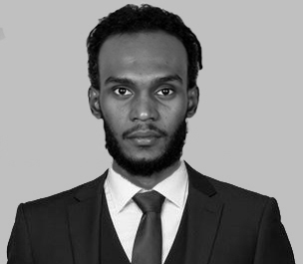

**B.CS** Information Technology

University of science & technology - Sudan

Sep 2017

**EDUCATION**

Diploma in comunicative English -

Tilak Maharashtra Vidapeeth University – India

Mar 2019

Ahmed Mohamedalkhier

**EXPERTISE**

Web Developer



Training & Courses

95%

80%

80%

75%

Programming Languages :

(HTML5 , CSS3 , Javascript , PHP)

Framework :

(bootstrap , Angular , Laravel)

Technologies :

(Ajax , JQuery , JSON , Node.js)

Databases :

(MySQL , Microsoft SQL Server)

Development Tools :

(Visual Studio Code , GitBash , Adobe XD)

90%

githup.com/AhmedTajalsir

Alnadiya Area, Ras Alkhaimah, UAE

ah.tajalsir@gmail.com

+97155 4208 430

I’m a nice, fun and friendly person, honest and punctual. I work well in a team but also on my own as I like to set myself goals which I will achieve, I have good listening and communication skills. I have a creative mind and am always up for new challenges and always plan ahead to make sure I manage my time well.

**ABOUT ME**

English

Arabic

Aptech Institute India, Pune

* Programing IN C - 40 hours

Jan 2020

* Jave programing - 72 hours

Jul 2020

* Programing IN C++ - 32 hours

Jul 2020

* Data Structures IN C - 24 hours

Jul 2020

Edureka Institute India, Bangalore

* Android Developer

Nov 2020

* Cybersecurity

Nov 2020

* Full stack web developer master program

Still studying the course online

**LANGUAGES**