**CURRICULAM VITAE** 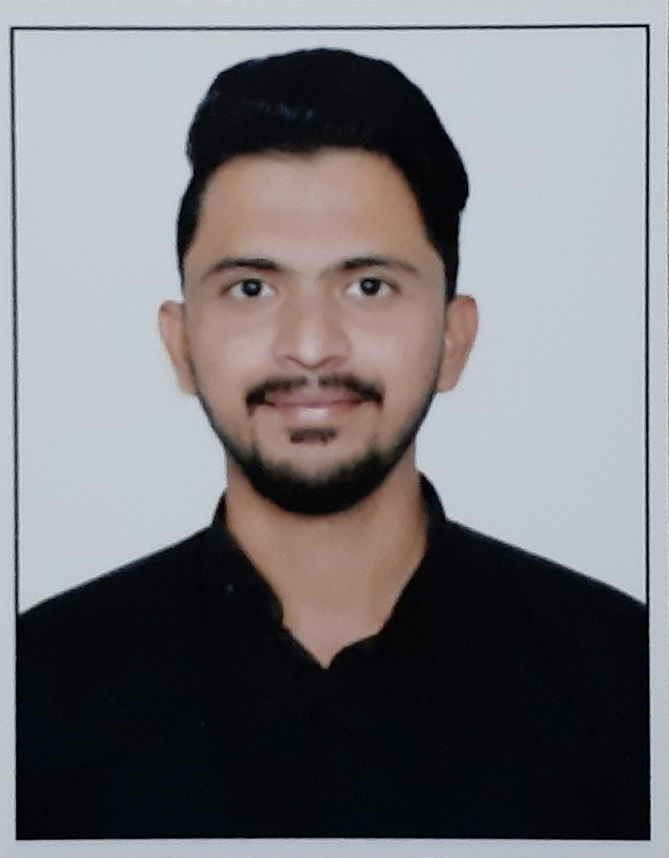

**UBAIDULLAH BABASAHAB JAMADAR**

**E-mail: ubaidjamadar19@gmail.com**

**Mobile: +919096100421, +917385784919**

# *OBJECTIVE*

To secure a challenging, fulltime position in an Industry that offers Professional Growth while being Resourceful, Innovative and Competitive.

# *TECHNICAL PROFILE*

* **2013SSC**from Al-Manar High School Chikhali,

And scored an aggregate of**79.40 %**

* **2015**Appeared **HSC** from Dr. D.Y Patil ACSJunior

College and scored an aggregate of **52.77%**

* Completed Diploma in Aviation, Hospitality & Travel Industry from Frankfinn Institute Of Air Hostess training

# *KEY STRENGTHS*

* Outstanding front office clerical abilities including typing and answering phones
* Familiar with all MS Office applications including Word and Excel
* Sound ability to resolve client or guest issues in a timely courteous manner
* Excellent relationship-building and communications skills
* Strong time management skills
* Ability to work varying shifts

# *WORK EXPERINCE*

**QUALITY INN MINT (FRONT OFFICE EXECUTIVE) 1st October 2018 – 5th November 2019**

* Managed front desk operations
* Passed room service requests to the correct staff members.
* Reviewed daily listings of reservations to look for and correct booking errors
* Managed multiple phone lines while attending to guest issues
* Responded to guest complaints in a professional courteous manner.
* Maintained an updated database of guest check-ins checkouts and fees.

[**SANA HOLIDAY RESORT PVT. LTD.**](https://www.tradeindia.com/Seller-3264056-Sana-Holiday-Resort-Pvt-Ltd-/) **(FRONT OFFICE EXECUTIVE) 10th November 2019 – 30th April 2020**

* Interacting with the guests to handle request for an accommodation.
* Maintained an updated database of guest check-ins checkouts and fees.
* Creating a guest’s account with the FO accounting system.
* Checking accommodation availability and assigning it to the guest.
* Managed multiple phone lines while attending to guest issues
* Takes [Messages](https://setupmyhotel.com/homepage/hotel-management-glossary/health-club.html), provides Directions to Guests, and maintains Mail.
* Fulfils any Guest Services related activities.

**SURYA MOTHER & CHILD MULTI SPECIALIST HOSPITAL (FRONT OFFICE EXECUTIVE) 11TH NOVEMBER – TILL NOW**

* Serves patients by greeting and helping them, scheduling appointments, and maintaining records and accounts.
* Welcomes patients and visitors in person or on the telephone, and answering or referring inquiries.
* Optimizes patients’ satisfaction, provider time, and treatment room utilization by scheduling appointments in person or by telephone.
* Comforts patients by anticipating patients’ anxieties, answering patients’ questions, and maintaining the reception area.
* Ensures availability of treatment information by filling and retrieving patient record
* Obtains revenue by recording and updating financial information, recording and collecting patient charges, controlling credit extended to patient charges, controlling credit extended to patients, and filling, collecting, and expediting orders for supplies, and scheduling equipment service and repairs

* Collecting Information Of Different Fields

# *HOBBIES*

# *ERIENCE*

* Playing & Watching Football
* Travelling

# *PERSONAL INFORMATION*

* Date of Birth : 10 December 1996
* Birth Place : Pimpri, Pune
* Gender : Male
* Nationality : Indian
* Marital Status : Single
* Languages : English,Urdu, Hindi,Marathi.
* Permanent address : 11/86, vallabh Nagar,

Pimpri, Pune – 411018.

# *DECLARATION*

I do hereby declare that the particulars of information and facts stated herein above are true, correct and complete to the best of my knowledge and belief.

Place: Pimpri, Pune Ubaidullah Babasahab Jamadar

Date: