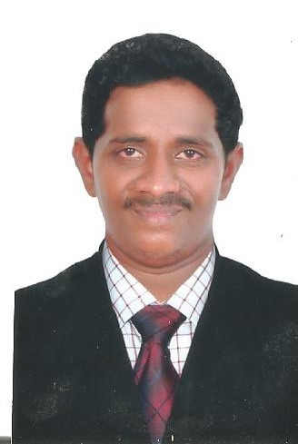  B. SAHAYA ARUL JALOUSE  +91 9698184396  Jalous120@gmail.com  Personal Details:  Date of Birth: 24 June 1990  Marital Status: Married  Nationality : Indian  Passport Details:  Passport No : L2325259  Place of Issue: MADURAI  Valid up to :18-06-2023  Interests:  Sports, music and traveling.  Languages known  English, Tamil, Malayalam, & Hindi.  Preferences:  Location: Willing to  Relocate, If an excellent opportunity is provided. | CAREER OBJECTIVE  To pursue a highly rewarding career, seeking for a job in challenging and healthy work environment where I can utilize my skills and knowledge efficiently.  ACADEMIC QUALIFICATION:  - Completed Diploma in Civil Engineering from Paster Lenssen Polytechnic College, Kuthenkuly in 2010 - 2013.  - Auto CAD - Civil, MS Office.  WORK EXPERIENCE:  Mithuna Construction Nuclear Power Plant (May 2019- Till Date)  Civil Supervisor ALFA AL-KHALEEJ Saudi Arabia(April 2016 – May 2019)  - Daily site inspection / project daily monitoring,  - Requesting and follow up the required materials.  - Check the availability of materials in every place of work.  - Conduct tool box meeting to the workers every morning.  - Check the quality of item in every place of works base on plan and specification.  - Supervised ongoing construction works , held part of the survey team, update daily  - Activities of constructions, estimating materials.  - Safely regulation compliance documentation.  - Discuss & obtain approval for Designs / Drawings / Submittal with consultants/ client.  - Initiate and finalize interface /co-ordination drawings.  - Well CO-ORDINATION between company and client.  - Punch list clearing given from client and contractor.  - Assist consultant INCHARGE during inspection.  - Plan and monitor design and engineer activities.  - Punch list clearing given from client and contractor
Civil Engineering Suruthi Constructions Pvt, Limited India, Nagercoil , Tamilnadu.
(May 2013 – Jun 2014)

SOFTWARE EXPOSURE

- Platform : MS-DOS, WIN 95/98/2K/XP/VISTA.
- Packages : MS Office & Tally.
KEY SKILLS
- Extremely solid MS OFFICE knowledge
- Knowledge in use of spread sheets, database, word processing.
DECLARATION
I hereby confirm that the information given above is true to the best of my knowledge and belief.

PLACE : Yours Sincerely
DATE : B.SAHAYA ARUL JALOUSE

