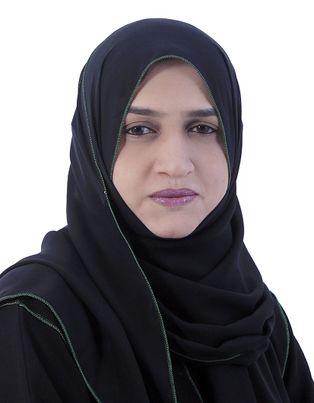

**CONTACT ME**



971-50-2854905



sugramirza@gmail.com



Dubai, UAE

**PERSONAL DETAILS**

|  |  |
| --- | --- |
| DOB | : 07-07-1981 |
| Nationality | : Indian |
| Marital status | : Married |
| Visa Status | : Employment Visa |
| Visa Validity | : till 2022 |
| Driving License | : UAE Valid |
| Languages  Fluent | : English, Arabic (Conversational), Hindi and Urdu. |

**COMPUTER SKILLS**

* Oracle Financial Software
* Oracle Management Operations
* MS OFFICE suit 7
* Windows XP, 7 Environment
* Internet and Email Management

SUGRA FATIMA

**PROFILE**

A meticulous Professional with more than **14 years** of experience in sales development, customer service, workforce development, and operations. Proven track record of searching out innovative, profitable solutions in challenging environments and leveraging strategies to realize superior results and consistent growth. Expertise in developing effective sales support mechanisms creating an efficient working relationship between sales and customer service and utilizing customer service data to improve sales approach.

**CORE COMPETENCIES**

|  |  |
| --- | --- |
| * Sales Operation Management | * Service Delivery Management |
| * Quality Assurance | * Customer Relation Management |
| * Business Support | * IT Assistance |
| * Process Improvement | * Pricing & Contracting Management |
| * Strategic Planning | * Financial Administration |
| * Business Planning and Forecasting | * Sales Force Segmentation |

**PROFESSIONAL EXPERIENCE**

|  |  |
| --- | --- |
| Jun 2014 – Jun 2020 | Senior Sales Operation Supervisor KIA Motors/Juma Al Majid Group, Dubai, UAE. |

**MAJOR ACCOMPLISHMENTS**

* Collaborate with the IT Department in implementing various solutions for KIA Management, evaluating day to day operations in oracle system for maintaining smooth sales cycle process and minimizing system errors.

**CHIEF ACCOUNTABIITIES**

* Spearheads team efforts in implementing improvement initiatives (Operational systems, process and policies) related to Back Office Operation.
* Receives & distributes upcoming stock of approximately 800 units in a month to buyers meeting bookings norms and policies as pre-reservation.
* Sets up standards/rules for the sales department to enhance internal operations and customer service quality.
* Assesses Oracle presales procedures and follow up on customer inquiries not resolved with sales staff.
* Organizes training sessions for new customer service representatives, sales coordinators and Sales staff on pre-sales oracle system.
* Evaluates market trends for updating prices of 1500 items (15 models of vehicles, each with 6-13 individual options & colors and other accessories) on Oracle system. Manage price discounts by Modifying GSA price list.
* Involved in Managing / controlling service contracts, preparing/submitting invoices and evaluating reports for nearly 2000 contract per year.
* Prepares / presents various Sales analysis and Sales ranking report for the senior management and sales strategy team to enable effective decision making on daily, monthly and quarterly basis.
* Handled issues related to moving and holding inventory in multiple locations.

|  |  |
| --- | --- |
| Mar 2009 – May 2014 | Sales Operation Executive KIA Motors/Juma Al Majid Group, Dubai, UAE. |

**MAJOR ACCOMPLISHMENTS**

**PERSONAL SKILLS**

* Excellent communication
* Data analytical skills
* Research skills
* Negotiation
* Time management

**PERSONAL SKILLS**

* Excellent communication
* Data analytical skills
* Research skills
* Negotiation
* Time management
* Problem solving ability
* Team Leadership
* Trend Analysis
* Planning abilities
* Motivation
* Multitasking

**EDUCATION**

**2003 Masters of Commerce**

Dr. Ramraju University, India.

**2000 Bachelor of Commerce**

Osmania University,, India

**CERTIFICATIONS**

**2014 SCRP**

Certified KIA Sales Consultant Recognition Program

KIA Motors/Juma Al Majid Group, Dubai, UAE

**2006 MANAGE YOUR TIME**

AAT Institute, India.

**2006 OFFICE MANAGEMENT**

Polgolla Open University, India

**REFERENCES**

* https://www.linkedin.com/in/sugra-fatima-972315a2

 Personal reference available on request.

* Gained leadership experience across a range of logistics functions, including inventory management, customer service, forecasting and distribution.

**CHIEF ACCOUNTABIITIES**

* Manage Bookings, Cancellation & transfer for maintaining stock availability

based on customer requirements for all over UAE sales.

* Follow up with stores for status of vehicle under work shop sub-inventory.
* Liaise with the warehouse in preparing/releasing vehicle based on specific requirements of customers for enhancing client satisfaction.
* Coordinate activities related to the “UAE Nationals Summers Jobs Program”.
* Interact closely with sales team and updated on work progress in sales order

status to achieve maximum results.

|  |  |
| --- | --- |
| Jun 2006 – Feb 2009 | Marketing Specialist KIA Motors/Juma Al Majid Group, Dubai, UAE. |

**MAJOR ACCOMPLISHMENTS**

* Coordinate all elements and material related to launch new website.
* Planned and executed initiatives to grow the business from Web queries.

**CHIEF ACCOUNTABIITIES**

* Monitor and recommend to improve website frequently and handled KIA info account.
* Created good relationship with sales team and motivate them to put in their best to work in order to achieve maximum results.
* Ensured that customers are treated cordially and are held in high esteem in order to make them patronize the company continuously and Handled Customer complaint.
* Evaluated sales records periodically to make balances and ensure that sales figures tally with number of web queries.

|  |  |
| --- | --- |
| Sep 2004 – Mar 2006 | Customer Care Executive HSBC Bank, Hyderabad, India. |

**MAJOR ACCOMPLISHMENTS**

* Managing the portfolio health by reviewing the key parameters indicating the quality of the portfolio. A strong MIS driven process having being designed and implemented for its objectives.

**CHIEF ACCOUNTABIITIES**

* Mobilization of comprehensive financial packages that includes Liability and Retail assets.
* Liability products (Priority banking accounts, commercial and corporate banking), Retail assets (Home loans, Personal loans, Educational loans and Credit Card).
* Handling inbound customer calls for various queries.
* Performing outside calls for new customers & existing customers to deepen the relationships and obtaining referrals as well as doing cross sell for new business.
* Managing complete back and operations, which include coordinating with the head office to provide more strength to the sales team.
* Managing tele verification to keep control over sourcing of fraudulent activities.