United Arab Emirates
Mohammed moffed Ahmed
+971588300844
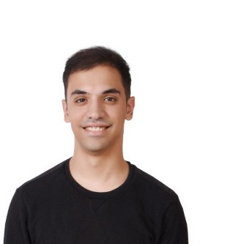
+971559478910
Selawe96@hotmail.com

OBJECTIVE

Seeking an opportunity to work diligently with my knowledge and skills in a reputable organization that offers both a good and challenging platform for career growth ...

Employment History

Amman Waves
● Customer Service / receptionists / Team Member
Amman, Amman Governorate
○ April 2017 – November 2017

Main responsibilities .
● Answering customers
Calls and slice there problems and fix any further issues.
● contact the owner for any future plans and obey orders .
● use Excel program and stock taking to find the net profit .
● making a various charts for employees job timings .
^{TRANSLATION OFFICE}
Translate diploma /master / PhD messages in Arabic and English literature .
○ November 2017- February 2018

Main responsibilities.
Translating PhD messages for more than ten students per week . ● use the simultaneous skills in Translating controversial videos with multinational speakers

● Fulfills requests by clarifying desired information; completing transactions; forwarding requests.

● Updates job knowledge by participating in educational opportunities.

Call centre in Jordan Macdonald’s sixth circle branch
○ since February 2018 – January 2019
Main responsibilities mentioned below
- attend Programs to learn about new products and services , and selling skills and receive technical assistance in developing new accounts
- Resolves problems by clarifying issues; researching and exploring answers and alternative solutions; implementing solutions; escalating unresolved problems.
- Fulfills requests by clarifying desired information; completing transactions; forwarding requests.
- Sells additional services by recognizing opportunities to up-sell accounts; explaining new features

High school
Al Abbas Bin Abdul Motaleb High School
High School Diploma
Graduated June 2014

Collage

Al Zaytoona University

Bachelor's Degree in English Translation
Amman, Amman Governorate
Graduated January 2019
Relevant Coursework: Consecutive Translation, Simultaneous Translation, Journalist Translation & Novel Literature Military history Translation course & Civil .

Skill set

- Detail-oriented, efficient and organized professional
- Having a long-term vision and leading a team of other professionals.Excellent skills, including advanced knowledge of MS Office (Power point ,Excel, autocad , etc)
- Supervising junior staff members.
- Using appropriate techniques to move others to action or to gain agreements.

Personal Information
Place of birth _ Jordan. Martual status _ single
Date of birth _ 12/9/96. Languages _ English, Arabic
Visa status _ tourist. Driving licences _ UAE

