**CURRICULUM** **VITAE**

**TUMAINI MWENDA**

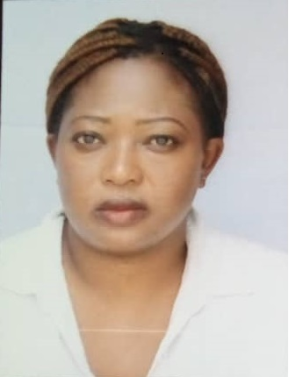

Dubai Internet City

Dubai

+971 569626785

[tumainimwenda50@gmail.com](mailto:tumainimwenda50@gmail.com)

Visa status: Visit Visa

**PROFESSIONAL SUMMARY**

Polite and positive Hostess with exceptional telephone etiquette. Proficient in assisting guests with reservations, valuables and baggage. Easily adaptable to change and able to perform well under pressure.

**OBJECTIVE**

To effectively contribute my knowledge to the attainment of goals with minimum supervision in line with set standards.

**SKILLS**

* Time management.
* Dining room management.
* To-go order preparation.
* Item promotion.
* Kitchen stuff coordination.
* Ordering procedure.
* Hospitality Service expertise.
* Customer service.
* Menu presentation.
* Food Running.

**WORK HISTORY**

**06/2019 - HOSTESS.**

**04/2020** **MARRIOTT HOTEL** – South Africa

* Resolved product issue through consumer testing.
* Completed tasks with accuracy and efficiency.
* Supervised staff members.
* Documented and resolved issues.

**EDUCATION**

**High school Diploma.**

**PERSONAL INRMATION**

Gender: Female

Nationality: Malawian

Marital status: Single

**REFERENCES**

Will be provided upon request.

**HOBBIES**

* Traveling.