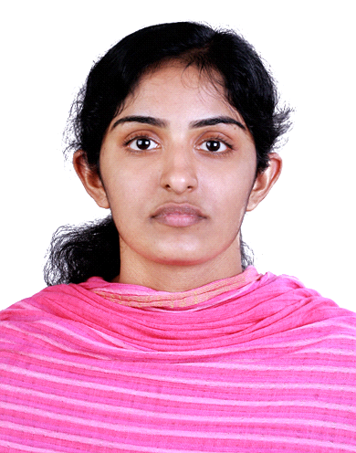

**JEENA MARY SANTHOSH**

**PARAMPATHU (H), MUTTAR P.O, ALAPPUZHA**

**MOB: +91 9847709906 +91 9847164591**

**E-mail: ammus3003@gmail.com**

**CAREER OBJECTIVE**

To acquire a better position in the area of Human Resource in a reputed firm and use my talents skills in management by being resourceful, creative and flexible

**PROFESSIONAL SUMMARY**

* An expert HR with proven expertise in implementing the policy and procedure, recruiting and hiring having 9 year hand on experience
* Skilled in attracting the most qualified employees and matching them to jobs for which they are well suited
* Excellent written and verbal communication skills
* Efficient in managing day-to-day administration, updating and maintenance of HR records
* Ability to meet deadlines and work under pressure
* Highly trustworthy, discreet and ethical

**PERSONAL QUALITIES**

* Innovative thinker and excellent leadership qualities
* Efficient in communicating well in writing and verbal both
* Strong problem-solving capabilities
* Energetic and proactive
* Excellent work ethic
* Strong interpersonal skills

**EMPLOYMENT DETAILS**

1. **BEGORRA INFRASTRUCTURE AND DEVELOPERS PVT LTD, KOTTAYAM**

**Title: Asst. HR Manager**

**Reporting To: Managing Director**

**Period: Oct 2020 till now**

1. **PUNNAMADA RESORT PVT LTD , ALAPPUZHA**

**Title: HR/ADMIN Manager**

**Reporting To: Managing Director**

**Period: Dec 2019 till Oct 2020**

1. **HOTEL INDRAPRASTHA, KOTTAYAM**

**Title: HR Manager Cum Front office Manager**

**Reporting To: General Manager**

**Period: Oct 2017 till Dec 2019**

**4. BELIEVERS CHURCH SYNOD SECRETARIAT, THIRUVALLA**

**Title: HR-Executive**

**Reporting To: HR Manager**

**Period: Dec 2011- June 2017 (5.6 years)**

**ACADEMIC DETAILS**

|  |  |  |  |  |
| --- | --- | --- | --- | --- |
| COURSE | INSTITUTION | BOARD/UNIVERSITY | YEAR | MARKS ( %) |
| MBA(HR ,Marketing) | Mangalam College Of Engineering Ettumanoor,Kerala | MG University | 2011 | 67 |
| BSC( Maths) | Marthoma College,Kerala | MG University | 2009 | 85 |
| HSE  (10+2) | St. George’s HSS Muttar,Kerala, India | Board Of Higher Secondary Education | 2006 | 79 |
| SSLC  (10th) | St. Thomas EMHSS, Neerattupuram, Kerala,India | Kerala State Board | 2004 | 72 |

**COMPUTER LITERACY**

* Expert in M S Office
* Internet savvy

**AREAS OF INTEREST**

* Human Resource Management
* Teaching
* Administration
* Banking

**HOBBIES**

* Cooking
* Surfing Internet
* Listening Music

**PERSONAL DETAILS**

* Date of Birth: 30-March 1989
* Marital Status- Married
* Permanent Address: Parampathu House, Muttar P.O, Alappuzha, Kerala, India-689574
* Sex: Female
* Nationality- Indian
* Languages Known- English ,Malayalam
* Passport Details: K5995208
* Date of Issue: 19/03/2013
* Date of Expiry: 18/03/2023

**DECLARATION**

I hereby declare that all the information mentioned above is true to the best of my knowledge I will make it my earnest endeavor to discharge competently and carefully the duties you may be pleased to entrust with me.

11-Feb-2021 ( S/d)

Muttar JEENA MARY SANTHOSH