**Resume**

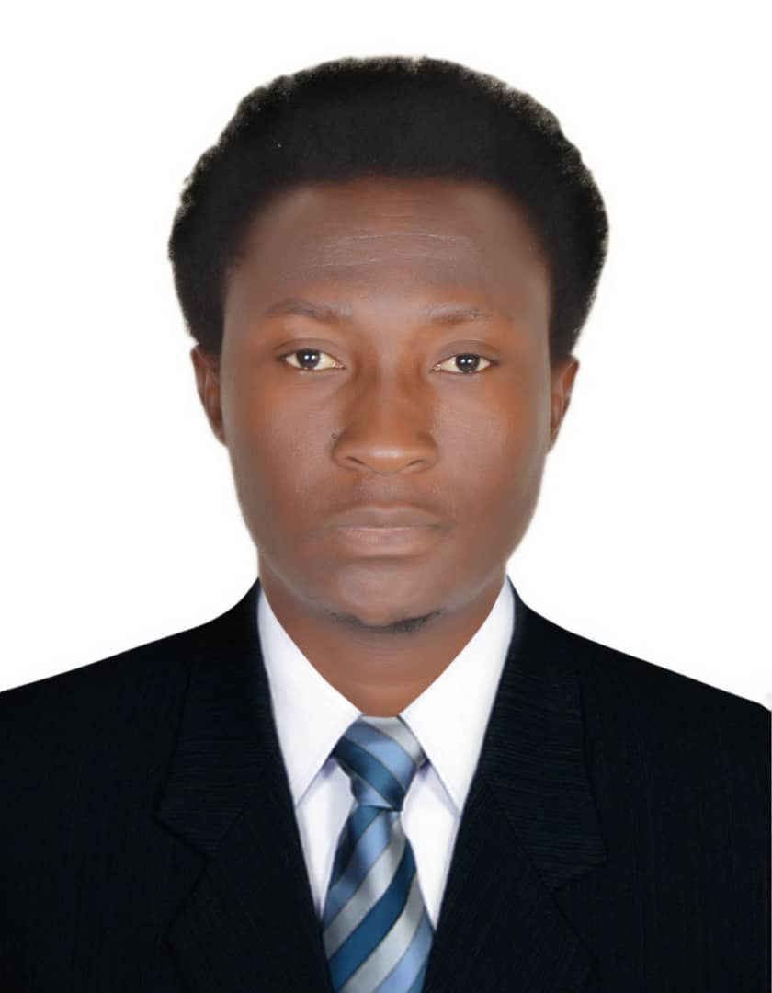

**NAME: Okpor Sunday Oghenekaro**

Email: brownzykaro@gmail.com

**MOBILE: +971547975275**

**VISA STATUS: cancelled visa**

**PASSPORT NO: A 10823394**

Gender male

Date of birth 05-29-1983

Nationality Nigerian

Language English

Religion Christianity

***Position applying for****: Cleaner*

**CAREER OBJECTIVE**

An enthusiastic salf-motivated individual with excellent inter personal skills the ability to take responsibility & work as a team. Possesses diversity of skills in managing projects and can work under pressure in a state where the objectives of the project is clearly defined. Quality & customer focused with the drive to achieve results. To seek a challenging & responsible assignment in a reputable organization, where i apply my current skills & knowledge.

**ACADEMIC PROFILE**

**HIGH SCHOOL COMPLETED:**

> Higher National Diploma (HND), Accounting, Akanu Ibiam Federal Polytechnic Afikpo Unwana Ebonyi State, Nigeria 2012.

> National Diploma: Delta State Polytechnic Ozoro, Delta State, Nigeria.

> High School: Notre Dame college Ozoro, Delta State Nigeria

> Primary School: Egwere primary school Ozoro, Delta State, Nigeria.

**WORKING EXPERIENCE**

**Work as a General Cleaning at Delta State Refinery Warri (2 Years)**

**Work as a General Cleaning at Osubi Airport (1 Year)**

**Work as a General Cleaner Lavaje, Musaffah Abu Dhabi (3years)**

**DUTIES;**

> Managed guest supplies and replenished as required.

> Provided optimal level of customer service for industry.

> Administered cleaning of floor, carpets and mattresses.

> Coordinated with housekeeping lead and ensured clean hotel rooms and hallways.

> Greeted all guests pleasantly and resolved all queries.

> Analyzed every room individually to ensure efficient cleanliness as per requirement.

> Assisted with product display and pricing.

> Clean corridors, stairways elevators and guest rooms.

> Organize work schedule form the rooms status list.

> Distribute linen, towels and room supplies using wheeled carts or by hand

> Replace dirty linens with clean items

**KEY SKILLS AND COMPETENCIES**

> Ability to handle heavy equipment and machinery used in cleaning

> Ability to walk, bend, push, pull and lift repetitively during working hours

> Excellent communication skills and the ability to work as a team

> Excellent organizational skills

> Self-motivation and the ability to identify and complete needed tasks without direct supervision

**PERSONAL**

• Ability to establish own work priorities.

• Can work effectively within established time frames and priorities.

• Cooperating with others to meet objectives.

**LANGUAGE PROFICIENCY**

English: Understands and Speaks and Writes

**LEISURE AND HOBBIES**

Board Games, Swimming, Travelling, Cooking, Football, Basketball