**CURRICULUM VITAE**

**Durgesh Kumar**

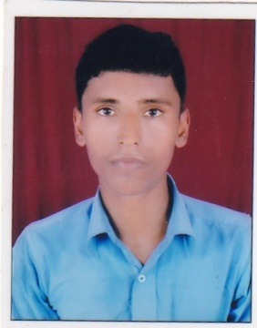**Address:**

E/26F Railway Colony City Station, Lucknow

Pin Code:-226018

E-mail ID: [dk8091411@gmail.com](mailto:dk8091411@gmail.com)

Date of Birth: 16 Nov. 1994

Mob No: (7068614127, Indian); (Saudi Arabia-530624072)

**Profile :**

My name in an accomplished Sales Manager with 5 years of experience as a Sales Manager he has proven success in organizing task, increasing sales and multiplying business from limited material and resources is searching for a hospitality industry where my experience and skills would be put in use.

**Objective:**

Applying 5 years of Indian “**Agarwal Cycle and Fitness”** experience combined with proven expertise in managing a high end cycle store and fitness.

**Education:**

B.A. From Deen Dayal Upadhaya Degree College, Gorakhpur (Uttar Pradesh),  India

**Language:** Hindi, and Arabic

**Specialization skills:**

1. Excellent interpersonal and communication, skills.
2. Multi tasking abilities with proficiency in organizing and managing different tasks.
3. Expert knowledge of handling administration and paper work.
4. Skilled and Book keeping and preparing statistical and financial record.
5. Through insights in overseeing stock levels and ordering supplies.
6. Proficient in assigning duties and scheduling shifts.
7. Ability of recruiting training and supervising staff.
8. Expert marketing skills to promote business.

**Sales Manager:-**

Agarwal Cycle and Fitness is the popular cycle and       fitness located

in Kapoorthala, Lucknow-226020, Uttar Pradesh(India)

**Responsibilities and Role Details:-**

1. Managing operations of high volume cycle and fitness organize staff of over 25 employees.
2. Co-ordinate administration, budget, payroll staff and vendors.
3. Maintain high standard quality hygiene, health and safety.
4. Recruiting, training and motivating staff.
5. Generating detailed daily, monthly, quarterly and yearly reports on business, staff

With regards,

Date: Yours sincerely

(Durgesh Kumar)