KAIMAPARAMBIL House

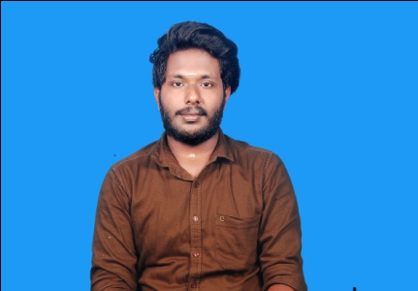 AZHIKODE JETTY.P.O.

KODUNGALLUR

Thrissur.Dist.

Pin – 680666

Mobile: 9061902824

email:amaldachoos@gmail.com

**AMAL. K. SURESH**

|  |
| --- |
| ***Career Objective*** |

To obtain a meaningful and challenging position that enable me to learn and contribute to management field as well as allow for career advancements.

|  |
| --- |
| ***Education Qualification:*** |

|  |  |  |  |  |
| --- | --- | --- | --- | --- |
| **Course** | **School / College** | **University** | **Year of passing** | **Percentage** |
| CMA Foundation | ICMS | ICWAI | 2017 | completed |
| CMA  INTER | ICMS | ICWAI | Doing |  |
| B.Com | ICMS | Calicut university | Completed |  |
| Plus Two | GHSS | Higher Secondary Education Board | 2017 | 67% |
| S.S.L.C | SSMHS | Kerala State Board of  Exam. | 2015 | 91% |

|  |
| --- |
| ***Computer Knowledge*** |

* Ms Office (MS Word, MS Excel)
* Internet & Basic
* Tally

|  |
| --- |
| ***Personality Traits:*** |

Self-Motivated, Open mind, Straightforward, Effective team player, Commitment to Life-long learning.

|  |
| --- |
| ***Strengths:*** |

* Good analytical, Technical and decision-making skills.
* Always maintains an optimistic mentality despite of adverse conditions.

|  |
| --- |
| ***Personal Detail:*** |

Name : **AMAL .K. SURESH**

Father’s Name : Suresh. K.S

DOB : 21/12/1999

Age : 19 years

Sex : Male

Nationality : Indian

Blood Group : B+ve

Religion : Hindu

Marital Status : Single

Languages known : English, Malayalam, Tamil ,Hindi

License Details : Having valid license of Two wheeler & Four wheeler

|  |
| --- |
| ***Passport Details*** |

|  |  |
| --- | --- |
| Passport No: | S6940685 |
| Date of Issue | 17-09-2018 |
| Date of Expiry | 16-09-2028 |
| Place of Issue | Cochin |

|  |
| --- |
| ***Declaration:*** |

I here above mentioned declared details are true and correct in my believe and knowledge.

Place : Thrissur

Date : **AMAL . K. SURESH**