abhinab divyajyoti mishra
POST GRADUATE DIPLOMA IN MANAGEMENT (PGDM In Finance)
Profile  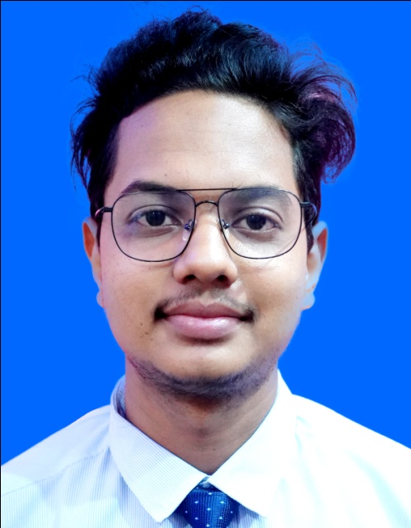  Focused Billing Clerk with 3 years of experience. Skilled in building client and vendor rapport And managing accounts to reduce outstanding balances. Hardworking and Energetic with passion for accuracy and efficiency.  Goal oriented Sales executive with 1 years of experience in sales. Proven  Leader with excellent salesmanship, negotiation and closing skills.  Contact  PHONE:  7381956497,  EMAIL:  meabhinablipun@gmail.com  Personal Info.  D.O.B – 26-03-1998  Nationality – Indian  Gender- Male  Address  At- Laxminagar, Dhabalgiri  Po- F.c Project  Jajpur Road,Jajur  Odisha- 755020  Hobbies  Photography |  | EDUCATION  10th  Jawahar Navodaya Vidyalaya, Angul  Year-2014  All general subject – 56%  +2 Commerce  Jawahar Navodaya Vidyalaya, Balasore  Year -2016  All General Subject- 72%  Bachelor in Commerce  Vyasanagar Autonomous Collage, Vyasanagar  Year -2019  Finance Hons.- 62%  WORK EXPERIENCE  HOTEL OFO HOSPITALTY SOLUTION Pvt. Ltd. [Sales Executive]  Jan-2016- Aug 2016  - Conduct market research to identify selling possibilities and evaluate customer’s needs.  - Ensure the availability of stock for sales and demonstrations.  Associated Travel Agency [Accounts Payable clerk]  Oct-2018–Aug 2020  - Process accounts and incoming payments in compliance with financial policies and procedures.  - Perform day to day financial transactions, including verifying, classifying, computing, posting and recording accounts receivables data.  - Prepare bills, invoices and bank deposits  - Reconcile the accounts receivable ledger to ensure that all payments are accounted for and properly posted.  SKILLS  Tax Reporting, Vendor Invoice Processing, General Ledger accounting, Product and Service sales, Operations, Sales Expertise, Inventory Control, Cash Register operations, Image Manipulations Retouching and colour corrections, Digital Photography, Visual Design  Food Photography

Place:
Date: Signature

