CURRICULUM VITAE
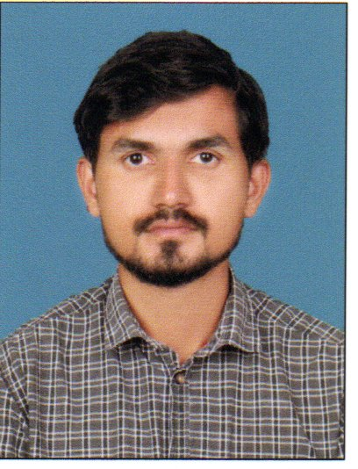

IRSHAD MOOSSA
KUNNAMANGALAM
Email Id: moossairshad@gmail.com
Mobile No.: 7356634661 (WhatsApp)

CAREER OBJECTIVE

Seeking a career in a reputable and dynamic organization, which will enable me to reach my potential as well as empower others and allow me to participate in a productive team environment. I am highly motivated by being involved in a dynamic, innovative, and challenging environment, which correlates to my personality.

WORK EXPERIENCE

Company : EMKE Group of Kitchen – Lulu Hyper Market
Location : Dubai
Designation : Supervisor, Floor Incharge in bakery section
Duration : 2010-2018

Existing Status : Operator of a Restaurant in Calicut

PERSONAL SKILLS

- Very good communication and interpersonal skills.
- Able to hold long engaging conversation with customer to put them at ease.
- Ability to empathize with people.
- Courteous at all times.
- Having a relaxed attitude and able to deal with awkward or rude customer.
- Excellent organization skills.
- Self motivated and can work under pressure.
- Exceptional communication skills, quick learner and able to adapt new technology.
- Effective working alone or as a co-operative team member.

ACCADEMIC CREDENTIAL

- SSLC from Chakkalakkal Higher Secondary school
- Plus Two from KMO English Medium Higher Secondary School

COMPUTER KNOWLEDGE

- Basic Computer Information Course (Ms-Office, Ms-Excel, Ms-Powerpoint),
Internet and E-mail
- Master Diploma in Multimedia Animation
- Well knowledge of use operating systems (Windows XP, Windows 7, Win 8,8. 1.9.10)

PERSONAL DETAILS
,

Name : Irshad Moossa. K. P
Date of Birth : 02/01/1989
Father’s Name : Moossa. K. P
Mother’s Name : Koulath
Permanent Address : Alakkumparambil House,
Muriyanal,
Kunnamangalam (PO),
Kozhikode – 673571
Sex : Male
Marital Status : Married
Nationality : Indian
Religion & Caste : Islam, Mappila
Languages Known : English, Malayalam, Hindi, Arabic, Tamil

PASSPORT DETAILS:

Passport No : R 2417177
Date of Issue : 18/02/2017
Date of Expiry : 17/02/2027
Place of Issue : Dubai

DECLARATION:

I do hereby confirm that the information given is true to the best of my knowledge.

Dear Sir/Madam
- I am interested in working as a part of your organization.
- I want to employ my experience and gain more.
- I will be available for an interview at your most convenient time.
- Thank you for your consideration

Irshad Moossa. K. P

