CURRICULUM VITAE

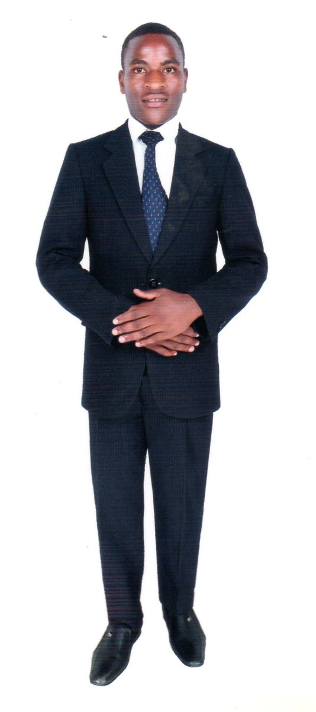
PERSONAL DETAILS
Name : Johnson Momanyi Moraa
Date of Birth : 30th Dec 1999
Gender : Male
Nationality : Kenyan
Marital status : Single
Religion : Christian
Telephone No.: +254 796938246
Weight : 60 kgs
Height : 5’4 ft
Passport : AK0546578
Languages : English and Swahili
Email address : sam012645@gmail.com

CAREER OBJECTIVES
To work in a dynamic and diversified companies to meet full challenges and utilize my learnt and intrinsic skills and proficient optimally for affirmative growth of the organization personal and career development.

Summary of Skills:
- Hardworking and professional at performing the job duties.
- Knowledge of handling both manual and automated tools used for cleaning various articles.
- Enough exposure to the organizational expectations about standards of cleanliness.
- Ability to converse politely with supervisors and team mates.

EDUCATIONAL BACKGROUND
2010-2013 Nyabimwa Secondary School
Kenya Certificate of Secondary Education

2002-2009 Nyabimwa Primary School
Kenya Certificate of Primary Education

WORKING EXPERIENCE
April 2017 To Date FLASH SERVICES LIMITED
Position: Cleaner
Duties and responsibilities
- Clean classrooms, hallways, and restrooms.
- Mix and handle various cleaning solutions and solvents; stored them properly and maintained inventory.
- Manage cleanliness of lawn areas, track oval, and activity centers; this includes landscaping work for the school greenery.
- Dispose of all waste in a proper manner and in accordance with local state regulations.
- Conduct minor repairs such as fixing gym equipment, doors and locks, broken windows and lockers.

Jan 2016-Jan 2017 SMART TOUCH CLEANING SERVICES
Position: Cleaner
Duties & Responsibilities
- Sweeping and mopping of the floor.
- Dusting, wiping, washing or polishing furniture, ledges, window sills, external surfaces of cupboards, radiators, shelves and fitments.
- Vacuuming all carpets and upholstery and removing all chewing gum.
- Dusting and polishing all chairs, tables and all drinking shelves.
- Emptying waste bins or similar receptacles, transporting waste material to designated collection points.
- Cleaning of washrooms to the required standard where allocated.
- Spraying cleaning, scrubbing floors and re-sealing with polish.
HOBBIES
- Traveling
- Watching football
- Sports
- Swimming

REFEREES
To be provided upon request.

