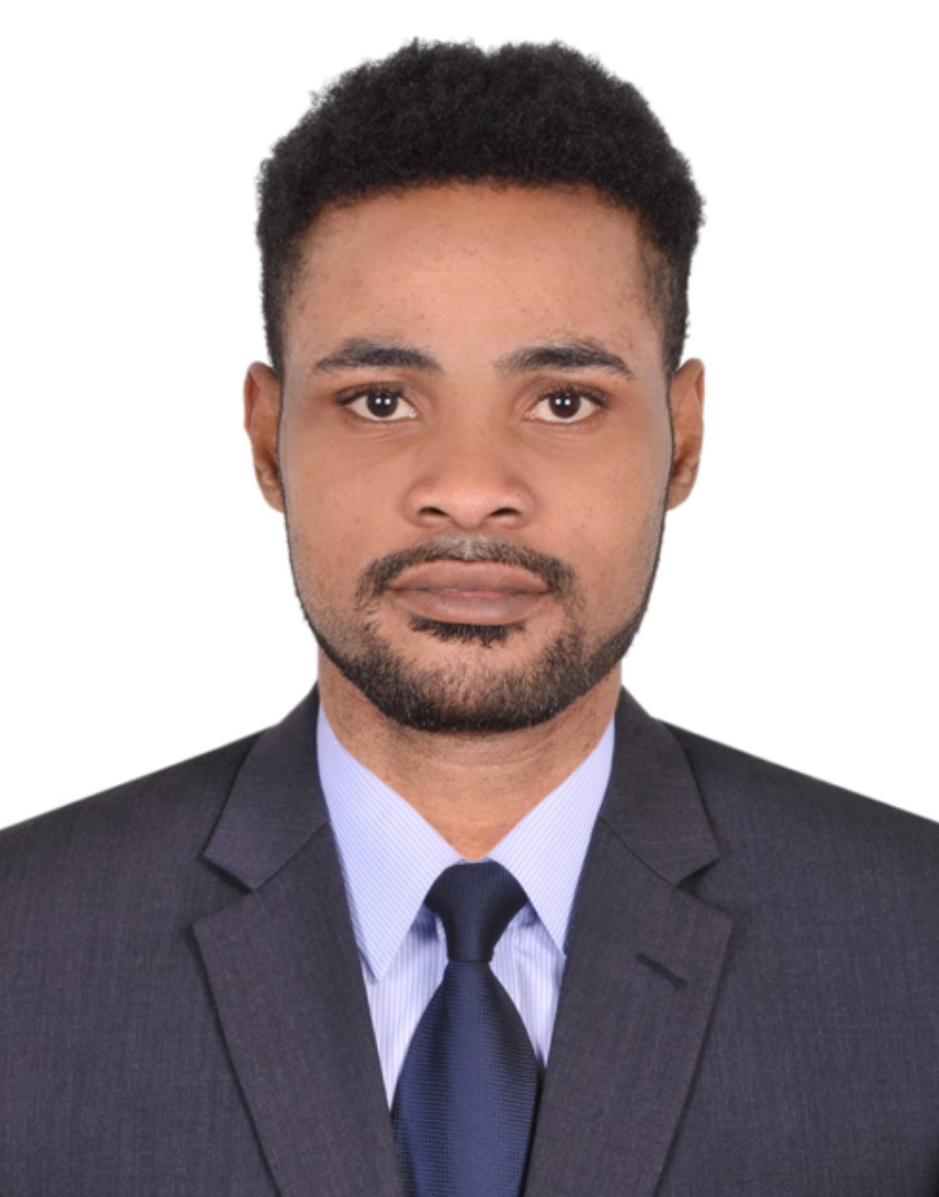
MICHAEL ADEOLA SHONEYE
Rolla Road, Bur Dubai, UAE.
+971554679160,
adeolamichael79@gmail.com

BIO-DATA
Date of birth: 10th of June 1986
Sex: Male
Nationality: Nigerian

MISSION
I seek to drive excellence, professionalism and profitability within an organization in order to provide services that meet customers’ demand and deliver high commercial value in the marketplace.

PROFILE
I am an effective and positive team player known for contributing and creating solutions as well as technical ability; able to give and embrace constructive criticism while working in a team environment towards a common goal; effective listener/communicator and fast diligent learner hungry for knowledge; productive worker under pressure and highly motivated.

Skill Highlights
MS Windows / Office  Account management  Guest experiences  Performance metrics  Fluent in English | CRM systems  Relationship building  Reservations  Quality assurance  Sales

EXPERIENCES:
SENIOR SALES ASSOCIATE ( SUPERVISOR )
ACE HARDWARE AL FUTTAIM UAE. 2019 - 2021
- Assist customer with special orders, providing information and resolving any issues.
- Constructed special orders for customers needing items not present in store.
- Work with a team in maintaining the presentation of the sales floor and keeping merchandise organized and fully stocked.
- Maintain stock on sales floor, updating stockroom inventory, answering phones, giving customers product information and recommendations.
- Assigned primarily to one zone on the sales floor, but worked in other areas as needed.
- Receive, store, and work all incoming merchandise to the sales floor.
- Stocked and maintained sales floor inventory; set up and maintained product displayed

SALES EXECUTIVE
AL RAIS ENTERPRISE (ACE HARDWARE SZR DUBAI) 2018 till 2019
- Executed complex strategic contractual negotiations at a senior level with existing accounts.
- Ability to demonstrate products and deliver effective sales presentations to win new business.
- Responsible for managing and growing an $8 million dollar client revenue base through existing and new accounts.
- Developed channel partners to increase company-wide sales leads and industry partnerships.
- Negotiated contracts, marketed company involvement, and organized participation yearly in trade shows that increased sales for Growth Sales Team and improved brand recognition.
- Executed professional presentations at events and consultations to municipalities on effective recycling programs and company services.

RESERVATION AGENT 2015 - 2018
ROTANA HOTELS, AL AIN, UNITED ARAB EMIRATES.
- Sold room reservations and made changes to existing reservations in a knowledgeable and timely manner
- Helped Group Sales Coordinator maintain rooming lists
- Provided guests with the requested information concerning the facilities locations and surrounding area
- Processed all guest reservations including guest follow up obtaining all necessary information and accurately entering it into computer system
- Assisted Corporate Reservation Director and Reservations Supervisor with a variety of tasks not limited to brochure requests gift certificate processing and data entry

RESERVATION AGENT 2012 - 2015
HILTON HOTEL, AL AIN, UNITED ARAB EMIRATES.
- Sold room reservations and made changes to existing reservations in a knowledgeable and timely manner
- Helped Group Sales Coordinator maintain rooming lists
- Provided guests with the requested information concerning the facilities locations and surrounding area
- Processed all guest reservations including guest follow up obtaining all necessary information and accurately entering it into computer system
- Assisted Corporate Reservation Director and Reservations Supervisor with a variety of tasks not limited to brochure requests gift certificate processing and data
- entry

SALES EXECUTIVE 2010 - 2012
NEPCO HARDWARE, GARKI II, ABUJA.

- Reporting to the manager daily.
- Cleaning and tidying the store, and ensuring stock rotation was carried out for the following day.
- Processing customer transactions.
- Reminding customers about the store’s promotions.
- Making sure that the shop floor was always in pristine condition with displays perfectly maintained.
- Ensuring the store’s counter was always manned.
- Creating the shop window’s displays.

EDUCATION
2013: B.sc in Business Administration (B.Ed)
Olabisi Onabanjo University Ago Iwoye, Ogun state, Nigeria
2012: Higher National Diploma. Business Administration
Lagos State Polytechnic Ikorodu, Lagos State.
2003 – 2009: Stars International College, Ikorodu Lagos State.
Secondary School Certificate Examination (SSCE)

PROFESSIONAL CERTIFICATIONS AND ACHIEVEMENTS
Certificate of Achievement in Tourism and Hospitality Management. UAE
Certificate of Achievement in Telephone Operator and Customer Service. UAE
Certificate of Achievement in Revenue Management. UAE
Certificate of Achievement as Front Desk Agent. UAE
Certificate of achievement in Health and Safety Environment. UAE, DUBAI.
Certificate of Achievement in Making it Right. Hilton Al Ain. UAE
Certificate of Achievement as Laundry Supervisor. UAE
Certificate of Achievement as Best EHS Practice Award. UAE
Certificate of Achievement as Housekeeping Supervisor.
Certificate of Achievement in Human Resources Management & Organization.

REFRENCES:
Available Upon Request

