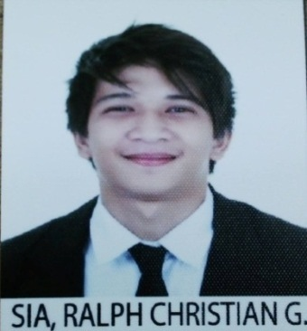**RALPH CHRISTIAN G. SIA**

Abu Dhabi, United Arab Emirates

Mobile Number: +971 56 870 0828

Email ID.: [xiansiaaa@gmail.com](mailto:xiansiaaa@gmail.com)

Visa Status: Employed

**OBJECTIVE:**

To obtain a position in an environment that offers a greater challenge where my skills are valued and can benefit the organization.

**CORE COPETENCIES:**

* Excellent background in back office works and office administration.
* Hands-on experience with MS Office Suite (particularly MS Word, MS Excel and MS PPT.)
* Exceptional interpersonal and written and verbal English communication skills.
* Can work with minimum supervision and can handle multiple tasks.
* Good interpersonal skills and adaptability to working environment.
* Keen on coaching and developing people, flexible and analytical.
* Well organized, hardworking, dynamic and can work under pressure.
* Excellent listener and time management skills.
* Team player, motivated and relationship builder.
* Typing Speed – Fluent

**WORK EXPERIENCE:**

**AD CAFÉ (FEBRUARY 2019-PRESENT)**

**ADMIN SECRETARY**

* Answers incoming internal and external telephone and personal enquiries, filters calls accordingly and checks answerphone, takes messages and forwards by e-mail or voicemail.
* Receives Visitors.
* Accepts deliveries along with the PO.
* Maintains tuck shop and coffee machine stock levels.
* Coordinate with the Barista for the stocks needed and ordered as mentioned.
* Coordinate with the Barista for the sales and make a report.
* Keeping invoices and receipts.
* Monitoring schedule of the shop.
* Reporting to the Owner and addressing the concerns if there is some.
* Writing letters and emails on behalf of the Owner.
* Arranging meetings internal and external as instructed by the Owner.
* Reviews e-mails and course it to the Owner or concerned person.
* Carrying administrative duties such as filing, typing, copying, binding, scanning etc.

# EDUCATIONAL BACKGROUND:

**Bachelor of Science in Hotel and Restaurant Management**

Far Easter University-Manila (2014-2019)

# PERSONAL DETAILS:

# Age: 23

# Birth Date: September 11, 1997

# Citizenship: Filipino

# Height: 5’6

# Civil Status: Single

*Supporting Documents and References will be provided on request

*I hereby certify that the information contained in this application is true and correct to the best of my knowledge.*

# Ralph Christian G. Sia

# Applicant