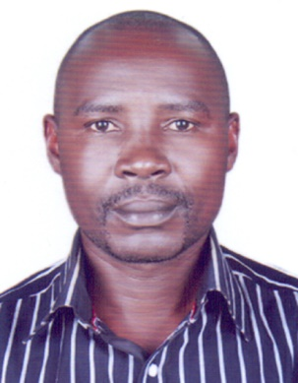 **CURRICULUM VITEA**

KAWOOYA DAVID

AbuDhabi-UAE

Mobile: +971-551868540

Email: kawooyadavid54@gmail.com

**APPLYING FOR GENERAL HELPER**

**OBJECTIVE**

To attain the challenging posting in the related field to work in an organization where I can enhance my skills and contribute to the growth of the organization as well. I assure you that I will work with full of my sincerity and do justice to my job and the organization.

# PERSONAL SUMMARY

Over Two years of extensive experience as a general helper highly skilled in assisting multiple departments with a wide range of tasks. Proficient in performing tasks pertinent to maintenance and deliveries Hands on experience in using office equipment and tools. In depth knowledge of performing routine clerical tasks as and when required.

# PERSONAL DETAILS

Nationality : Ugandan

Gender : Male

Passport No : B1401860

Visa status : Employment Visa

Language : English

#### WORK EXPERIENCE

I have 2 years Worked experience as a **GENERAL HELPER** at **ZZIMWE CONSRTUCTION**

**CO.** in Uganda and 1.5 years experience as a CLEANER at ME SERVICE LLC Abu Dhabi (UAE)

# RESPONSIBILITY

### Maintain clean and neat pantry and work area.

* + Loading and Offloading of goods.
  + Take good care of all cleaning equipment’s.
  + Dispose of all rubbish at compactor room before end of shift.
  + Report any outstanding matter before signing off.
  + Carry supplies to work area
  + Load cans on to conveyor belts and remove scrap

# SKILLS

### Ability to work with team spirit and to take responsibilities.

* + High level of concentration and commitment.
  + An excellent verbal and cross communication skills, diplomacy to work effectively with people and organization or any job assigned to me
  + Demonstrated ability to hold heavy weights
  + Profound ability to perform routine and repetitive work
  + Able to understand and follow written and verbal instructions
  + Comprehensive knowledge of using hand tools and cleaning equipment

#### PERSONAL PROFILE:

Self-Motivated, Sincere, Responsible and committed, Good interpersonal and team work skills.

Good communication and analytical skills.

Flexible and ability to work in multicultural environment.

**EDUCATION BACKGROUND**

High School Education

**REFERENCE**

I hereby attested the accuracy of information declared above as true and correct to the best of my knowledge and belief.