Curriculum Vitae

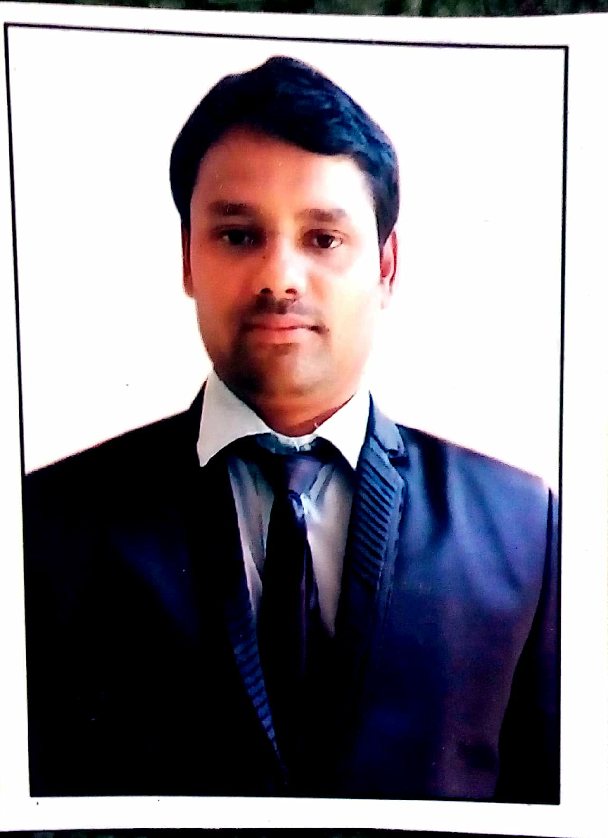

SAI KUMAR.M. V

sai.macharla2310@gmail.com

cell: +971 566589586

Objective:

To enhance my working capacities, professional skills, business efficiencies and to serve my organization in best possible way with sheer determination and commitment.

Qualification Summary:
- MS Management from Glyndwr University of Wales, UK (2010-12)
- Graduation (B.Sc. With Computer Science) – Pragathi Degree College, Nizamabad (2004-07)
- Intermediate (MPC)- Vishvodaya Jr College, Nizamabad (2000 – 02)
- 10th class (S.S.C), Raghava Public School, Nizamabad (1999- 00)
Professional Experience:

- Present Experience. : Store in charge in West Zone Supermarket in Dubai
- Recent Experience : Academic Co-ordinator/ Administrator/ Secretary in
Blooming Buds High School
- Tenure : 2yrs (Nov'17 - Dec'19)
- Previous Company : Maruti Suzuki India LTD (MSIL- Dealer)
- Tenure : 4yrs (Jul’14 - Sep’17)
- Job Profile : Customer Care Manager (Service)

- Previous Experience : SVR Multi Specialty Hospital
- Tenure : 2 Years (Apr’12- Feb’14)
- Job profile : Customer Service / Front Desk / Admin

- Previous Experience : Kronospan Facilities Management Services.
- Tenure : 1 Year 3 Months (Nov’10-Jan’12)
- Job profile : Line Supervisor

- Previous Experience : Swamy Dayanand high school, Hyderabad
- Tenure : 2 Years (Aug’08- Aug’10)
- Job profile : Academic In charge
- Previous Experience : Standard chartered Bank, Hyderabad
- Tenure : 1 Year (Jul’07-Jun’08)
- Job profile : Sales executive

Software Skills :-

Operating Systems : Windows 7, XP
Databases : SQL Server 2008 R2,
Tools & Utilities : MS-Office, HTML, Java Script basics,

Work Profile Description:

Store in-charge/Supervisor: West Zone Supermarket LLC, Dubai, UAE
- Maintain receipts, records, and withdrawals of the stockroom
- Preparation of the Purchase order and coordination with vendor for timely delivery
- Receive, unload, and shelve supplies
- Perform other stock-related duties, including returning, packing, pricing, and labeling supplies
- Inspect deliveries for damage or discrepancies and report those to accounting for reimbursements and record keeping
- Rotate stock and coordinate between branches
- Ensure adequate record keeping and manage all documentation to confirm proper stock levels and maintain inventory control

Administrator: Blooming Buds High School, Hyderabad, INDIA
- Worked as an Administration in charge in Swami Vivekananda International School of CBSE Syllabus in Hyderabad.
- Promoting our specialties of teaching methods and facilities available to the parents by conducting Parents meeting.
- Calls are made to Parents for the enrollments of their children.
- Handling receptionist calls to resolve Parents issues related with school.
- Conducting refresher sessions for the team.
- Driving quality initiatives in the team
Ensuring Customer Satisfaction
Customer Service Manager: Maruti Suzuki Dealer, Hyderabad, INDIA

- Previously working with Varun Motors Private Limited (MSIL - DEALER) which is based into Sales & Service of four wheeler vehicles.
- I’ll take care of different departments in the showroom from which the prominent departments are SMR (Service Marketing Report) & MCP (Maintenance cost Protect).
- Checking for any errors in the entire procedure of servicing regularly & analyzing the weak areas by finding out the Root cause and taking counter measures.
- Customer-centricity is one of the core stones of process and our focus is on retaining existing customers and attracting new customers.
- Taking customers feedback and analyzing the situation. Enacting according to the situation and resolving the issues.
- Leading, mentoring and monitoring the performance of the team members to ensure efficiency in process operations.

Accomplishments:

Present Job: -
- I have been a part of Steering committee in the company.
- Achieved highest ever CSI score in our workshop.
- 1st Prize Winner of the Regional Level (AP& Telangana) skills competition in 2015 conducted at Hyderabad
- 2nd Prize winner of the National Level skills competition in 2015 held at Bangalore.
- Received appreciation mails from Management for the Development of team in customizing procedures, Modifications and Updating the team members.
- Represented Company by attending seminars at different branch venues.
- Helped HR team in recruiting CCE’s in very short span.

Key Skills:

- Understanding product and utility tools.
- Punctuality and time maintenance.
- Negotiating skills acquired by handling customer objections.
- Exposure to international work culture with deep understanding of business practices.
- Quick learner and adaptability to the stressful work environment.
- Maintain good customer relationship.
- Dedicated team player, committed to providing high-quality support and excellent problem solving skills to all organizational levels.

Personality Traits:
- Excellent communication and interpersonal skills.
- Ability to give the best result in pressure situations.
- Excellent problem solving skills.
- Goal oriented.
- Leadership skills.
- Motivational skills.
- Optimistic and hardworking.

Personal Profile:
Name : M.V.Sai Kumar
D.O.B. : 24th April, 1985.
Marital Status : Married
Nationality : Indian
Languages Known : English, Hindi and Telugu
Passport : R0647463
Validity : 19/06/2027
Visa Type : Employment Visa
Visa Validity : 30th October 2022
Permanent Address : H.no:10-8-56, near Barsing Baba Mandhir,
Gajulpet, Nizamabad.
Telangana, India
Place:
Date: (M.V.SAI KUMAR)

