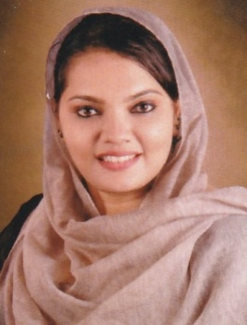

JERIN BASHEER

COCHIN,KERALA-+917902216930.

[jerinbasheer@gmail.com](mailto:jerinbasheer@gmail.com)

**PROFILE & STRENGTHS**

To gain meaningful employment with a company that will allow personal and professional growth without limiting the opportunity for further enlightenment and enhanced education. Highly motivated and committed professional with 10 years experience in the travel industry. Experienced in all aspects of the travel and tourism industry. A pleasant, friendly and outgoing personality.

**Work Experience** :

Akbar Travels Online.Com, Kakkanad Cochin :Since Aug 2010 to Sept 2018.

World Yathra Tours and Travels, Cochin : Since Oct 2018 to till date.

**Operations Manager (Ticketing, Visa, Tour)**

**Skills**

* IT literate and fully up to date with the latest technology and booking systems.
* Excellent verbal and non verbal communication skills.
* Proven expertise at network and negotiating.
* Ability to quickly assess the customer’s need.
* Maintaining a confident and professional demeanour at all times.

**Responsibilities**

* Managing the team and entire operations of the branch
* Creating profit for the organization through day to day business target
* Managing accounts and profitability of the branch
* Managing the ticket issuance and tour package assistance
* Organizing Flights, Travel insurance, Visas and accommodation.
* Using a booking system to secure Holidays
* Collection and processing payments.
* Advising customers on travel arrangements.
* Keeping clients promptly informed of any changes and offering suitable alternatives when appropriate.
* Handling complaints and refunds.
* Maintaining the data of clients.
* Managing the team for daily activities.

**Technical Qualifications:**

* SABRE
* GALELIO
* ONLINE TICKETING
* ONLINE VISAS
* Diploma in Computer Designing

Educational Qualifications:

|  |  |  |
| --- | --- | --- |
| Name of Examination | Board /Institution | Year of Passing |
| B A ECONOMICS | Bharathiar University | 2006 |
| HSE | Board of Public Examination, Kerala | 2003 |
| SSLC | Board of Public Examinations, Kerala | 2001 |

Personal details:

Full Name : JERIN BASHEER

Address : REGAL COUNTY

COSMIA A 13C

COCHIN, KERALA

INDIA

PIN – 686507

Fathers Name : BASHEER V.M

Date of Birth : 12.06.1985

Nationality : Indian

Sex : Female

Religion : Islam, Muslim

Marital Status : Married

Contact Number : +91 7902216930

E –mail : [jerinbasheer@gmail.com](mailto:jerinbasheer@gmail.com)

Reference :

Mr. Abdul Raheem *(Manager)- +919037727737.*

DECLARATION

I hereby declare that all the information furnished above is full and true to the best of my knowledge and belief. And I also assure you that I can be always a functional unit and the development and progress of organization.

Date:28.01.2020

Place :COCHIN JERIN BASHEER