Curriculum Vitae
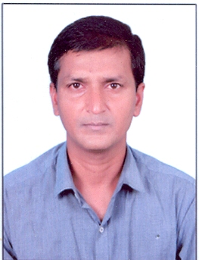

Syed Khaja Ansar Hussain Mobile:+917095676892
Email:syedansar850@gmail.com

Objective:
Looking for a challenging job in dynamic organization where I can utilize my potential to its full extent in the field of Sales / Administration that gives me a chance to use my abilities for the betterment of the organization and to learn new updates.
Professional Experience:
Position | Organization | Location | Start From | Till
Visa Coordinator | ALAMWAJ ALKHULUD TRAD EST. | Riyadh, KSA | 2017 | 2019
Merchandiser | AL-NAGHI BROTHERS (Gillette Div) | Riyadh, KSA | 2013 | 2014
Merchandiser | BA ABDULRAHIM TRAD EST. | Riyadh, KSA | 1999 | 2012

Work Experience (Duties & Responsibilities Handled):
(Visa related processing)
- Typing of documents for Visa application to various countries.
- Payment of relevant fees to embassies as per the guidelines.
- Facilitating Hotel booking and Air ticket reservations.
- Processing Medical and Tourist visa applications.
- Arranging embassy appointment dates as per client requirements and availability.
- Coordination with VFS offices and submitting accurately the applications to VFS.
- Experience in handling USA/UK/European VFS processing including stamping/stickering etc.

(Sales related processing)
- Visiting potential customers and marketing company products.
- Presentation of samples and demonstration.
- Arrangement of display with visibility of labels properly.
- Checking the damaged products.
- Making new customers and sustaining long lasting relationship with customers.
- Attending sales meetings.
- Maintaining an accurate record of all sales, schedule customer appointments.
- Achievement of set targets.
- After sales support to potential customers to ensure customer satisfaction.
- Developing in depth knowledge of company products.

Driving License:
Can drive 4 wheeler light vehicle (had driving license in KSA).

Languages Known:
Can Read and Write in English, Can speak good Arabic and Urdu is mother tongue.

I hereby declare that all the above information is true and correct to the best of my knowledge and belief.

SYED KHAJA ANSAR HUSSAIN

