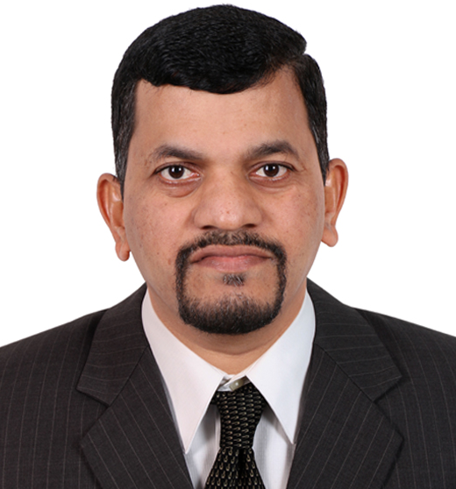

**KAILAS SITARAM JADHAV**

Contact*🖁*: +918793846459

Email: ruchijadhav02@rediffmail.com / [ruchijadhav02@yahoo.com](mailto:ruchijadhav02@yahoo.com)

**SR. PROFESSIONAL – PROJECT/OPERATIONS/MAINTENANCE**

**INSTRUMENTATION**

**CAREER OBJECTIVE**

To be a Dedicated, Resourceful, and Innovative Professional, can be headhunted

by spearheading the efforts across reputed organizations as a Sr. Professional –

Project Management/Operations/Maintenance to achieve management vision/goals in planned & stipulated time frame by capitalizing my Education & Practical Experience in possible way.

**PROFESSIONAL SYNOPSIS**

* Core Strengths in project planning, scheduling, monitoring, Commissioning,

Awarding work contracts and execution of projects without incidences of time/cost overruns.

* Excellency in Instrumentation, systematizing maintenance function with

implementation of predictive, planned & preventive maintenance practices to

maximize functional availability of equipment.

* Adept at designing & implementing quality systems and procedures to ensure

strict adherence to quality parameters.

* Excellent man-management, time management, and leadership skills.
* Having 25+ years of experience in project management, operation & maintenance in innumerable industries in different capacities.

**BASKET OF KEY COMPETENCIES**

* Project Management Operations/Maintenance  Budgeting

& Cost Control

* Instrumentation Erection/Commissioning Resource

Planning/Quality

**PROFESSIONAL EXPERIENCE**

**PENTOKEY ORGANY (I) LTD. FROM: 26 NOV 1996**

**(Manufacturing of Acid/Ester) TO: 11 SEP 1999**

**INSTRUMENTATION SUPERVISOR**

* Carried out Calibration, Loop checking, and Functional checking activity.
* Preparation of JB terminal drawings, cable drum schedule, and instrument

loop drawings.

* Co-ordination with other disciplines, vendors, clients and contractors.
* Preparation of plot plans, hook-ups, cable listing, cable length estimation, air

header schedule etc.

* Review and comment on cable block diagrams, location layouts
* Responsible in maintaining all Department Records and file related to the

above function.

* Responsible in performing all other works assignment by the Department

Manager.

**RALLIS INDIA LTD. CHIPLUN, INDIA FROM: 20 SEPT 1999 (Manufacturing of Pesticide) TO: 23 SEPT 2006**

**INSTRUMENTATION SUPERVISOR**

* Accomplished responsibility for erection & commissioning of various

instruments within scheduled time/budget.

* Structuring annual operational budget and implementing control measures to

contain expenses within defined limits.

* Meticulously implemented safety/environment systems/procedures with

periodic reviews.

* Responsible for Smooth running of Electrical Systems.
* Responsible for Preventive Maintenance of Electrical Equipment/Instruments.
* Troubleshooting of Instrument/Electrical Problems.
* Responsible in maintaining all Department Records and file related to the

above function.

**USV LIMITED. CHIPLUN, INDIA FROM: 24 SEPT 2006**

**(USFDA Approved Plant, TO: 25 JULY 2009**

**Manufacturing of Multiple Drugs)**

**EXECUTIVE- INSTRUMENTATION**

* Responsible for the quality control and assurance, performs planning and

supervising of all field quality verification and inspection activities,

monitoring adherence to drawings, specifications and standards.

* Instrumental in framing on-site and off-site Emergency Management Plans

and conduct safety drills periodically to familiarize the personnel with

Emergency Management Plans.

* Formulated plan for ensuring Quality through quality auditing, quality

evaluations and declaration of quality ratings etc.

* Involved in the various commissioning activities like loop checking,

calibration, sequence & function checking of the Air compressor,

commissioning. Other process instrumentation backed up by PLC systems.

* Commissioning of field instrumentation and YOKOGAWA CENTUM CS1000

Distributed control systems.

* Proactively contributed in PLC communicating with SCADA system with

Wonder-ware Software.

* Responsible for carry out various Qualifications (DQ/IQ/OQ/PQ) required

for Equipment Installation.

**GHARDA CHEMICALS. CHIPLUN, INDIA FROM: 25 JUL 2009**

**(Manufacturing of Chemicals, TO: 28 DEC 2010**

**Fertilizers, Power, R&D)**

**INSTRUMENTATION ENGINEER**

* Overall responsible for managing erection, commissioning & maintenance

activities of fully automated DCS of Rosemount RS3 system, PLC of ABB

5/25 and 5/60 and Emerson Delta-V, Foxboro Invensys I/A Series,

SCADA (Intellution) enrolled process plants.

* Reduced the consumable cost of maintenance by emphasis on preventive/

predictive maintenance.

* Proactively contributed in PLC communicating with SCADA system

FLXDMACS of Intellution.

* Guided & mentored the team in preventive/corrective Maintenance,

overhauling & calibration of all types of control valves & accessories and

Telephone systems.

* Organized various training sessions for the team to enhance

performance.

* Ensured timely calibration of all instruments, gauge’s, weighing m/c for

complete reliability & functional correctness.

* Propagated Quality Circle movement and developed quality culture in the

work force to achieve quality leadership in the industry.

* Credited for implementing ISO in various depts. and maintaining its

documentation.

* Involved in the various commissioning activities like loop checking,

calibration.

* Gained invaluable experience of working on Radar/ULTRASONIC level

instruments, Control Valves, Flow Meters, Smoke/Gas Detectors, PH/

Conductivity Transmitter, O2 Analyzer, Solenoid/PC/Pilot operated valves,

Level Transmitter displacer etc.

* Fully accountable for Conceptualizing, designing, planning & monitoring the

CPF Project that consisted of 80 closed 100ps with 3000+ input/output –

process variables connected to Rosemount system 3 (Rs-3) DCS, Delta-V &

Allen Bradley 5/25, 5/60 programmable logic controllers.

* Instrumental in framing on-site and off-site Emergency Management Plans

and conduct safety drills periodically to familiarize the personnel with

Emergency Management Plans.

**TASNEE PETROCHEMICALS IND. COMPANY FROM: 2 FEB 2011**

**(SAUDI ARABIA) TO: 2 FEB 2022**

**(Manufacturing of PE, PP, LDPE, HDPE, EC)**

**SENIOR TECHNICIAN-INSTRUMENTATION**

* Installing, managing, and maintaining equipment.
* Inspect equipment and systems. Provide preventative maintenance services.
* Troubleshoot malfunctions of computerized control devices, control, and instrument loops
* To maintain Department KPI.
* To update and maintain the SAP system.
* Maintain and update files, records, reports, and logs.
* Respond to emergency calls for service on a call-out basis and work outside normal working hours as needed.
* Inspect equipment and systems. Provide preventative maintenance services.
* Troubleshoot malfunctions of computerized control devices, control, and

instrument loops.

* Responsible for Calibration, Loop checking and Functional checking activity.
* Responsible for maintaining all Department Records and file related to the

above function.

* Responsible for Smooth running of instrumentation Systems.
* Responsible for Preventive/Predictive Maintenance of Instruments.
* Responsible for Corrective Maintenance of Instrument Problems.
* Responsible for maintaining SAP system records.
* Handling On-Call Responsibilities.
* Handling Delegation of Supervisor.

**SKILLS**

* Teamwork and collaboration.
* Professionalism and strong work.
* Strong work ethic.
* Leadership.
* Oral and written communications skills.
* Critical thinking and problem solving.

**ACADEMIA**

* S.S.C. Passed with First Class.
* H.S.C. Passed with First Class.
* Diploma of (Industrial Electronics) from Mumbai University. Passed out in 1994 with First class.

**OTHER QUALIFICATION**

* Diploma in Information System Management.
* Diploma in Industrial Engineering.
* Government Commercial Certificate Examination (English T/W, Speed 30 W.P.M.)
* Maharashtra State Certificate in Information Technology.

**SAFETY AND OTHER TRAININGS**

* Fire Prevention and Fire Fighting.
* Personal Safety & social responsibilities elementary First Aid.
* Completed Medical First Aid Training.
* Risk assessment and Job safety Analysis.
* Safety Equipment’s Operation Training.
* Completed one Week course on SIEMENS PLC (S7-300 and S7-400).
* Completed one Week Control Valve Maintenance and Troubleshooting Course.

**PERSONAL INFORMATION**

* Date of Birth: 11th May 1975.
* Marital Status: Married.
* Sex: Male.
* Languages Known: English, Hindi, and Marathi.