**Resume** 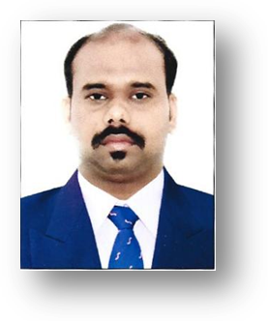

***ABDUL MALIK***

* ***Email :******thaslimaabdulmalik@gmail.com***

***Mobile: +9710589344710***

* ***mobile : +919361430722***
* ***mobile: +96551443414***

***Professional summery***

***Highly skilled and meticulous call centre representative with a superb record of customer satisfaction and successful sales. Adept multitask able to address multiple customer and company tasks with the highest degree of professionalism and accuracy flexible scheduling availability to include evenings weekends and some holidays..***

***Call centre***

* ***provided telephone customer related service***
* ***managed and collected information and resolved customers***
* ***made a target for speed and quality sales***
* ***handled the complicated customer inquires patiently***
* ***provided excellent customer service***
* ***attended training and seminars to improve one's capability***

***Experience***

* ***2 years and 6th month experience in food & beverage waiter in charley’s and subway restaurants in Kuwait in the year 2011 to 2014***
* ***6 years experience in Kuwait fast food industry working as a call centre agent in subway and rock house sliders in the year 2014 to 2020***

***Educational***

* ***Intermediate passed in the year 2007***
* ***Matriculation passed in the year 2009***
* ***Diploma hotel management in the year 2010***
* ***Diploma in computer application***

***Skills***

* ***Good listening skills. Practice active listening - don't interrupt customers, but engage them***
* ***Multi-tasking ability***
* ***Excellent problem-solving capabilities***
* ***Computer experience***
* ***Can read Arabic customer special request***
* ***Outgoing and energetic attitude. It's a fact: We've all had bad customer service over the phone***
* ***Speed typing***

***Language***

* ***English***
* ***Arabic***
* ***Hindi***
* ***Tamil***

***Personal details***

* ***name { Abdul malik***
* ***date of birth { 07-04-1990***
* ***gender { male***
* ***marital status { married***
* ***national { Indian***

***Passport details***

* ***Passport number { T8210217***
* ***Date of expiry { 03-11-2029***
* ***Date of issue { 04-11-2019***

***Declaration***

***I confirm that above furnished information are true to the best of my knowledge and can be Support with relevant document.***

***Signature of applicant***