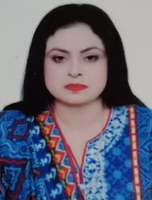

CURRICULAM VITAE

Satatus: 3 month visit visa(10Mar to 05 Jun)

**Carrier Objective**:

Accept and enjoy the new situation and challenges, make positive contribution towards the given position, increase the wealth of organization and enhance the knowledge, abilities and skill through the organization by contribution.

**Personal Data:**

**­Name : Firdous Salmoon**

**Husband Name : Salmoon john**

**Passport no : LK5751271**

**CNIC no : 38201-4282127-6**

**Date of Birth : 15/07/1985**

**Nationality : Pakistani**

**Marital Status : Married**

**LANGUAGES : Urdu / Hindi / English**

**CONTACT**

Tel /Email : +971562564953 (UAE)

: +971565107528 (UAE)

: pinkychohan34567@gmail.com :

­**Qualification:**

M.A (Political Science) 2013 University Of Sargodha.

B.A 2007 University of Punjab.

F.A 2005 B.I.S.E Sargodha.

Matriculation 2003 B.I.S.E Sargodha.

­­­­**Computer knowledge:**

Ms Office

E-Mail & Internet

**Work Experience**:

1 year experience as a teacher in Venus Model High School Jouharabad.

1 year experience as a teacher in Angelic Public High School Jouharab

1 year experience as a Personal assistant at Otbah Medical College Jouharabad.

2 month experience as a surveyor in CPDI(center for peace Development Initiative)

General Elections 2013 **ELECTION Observation.**

1 year worked as Receptionist in Superior college Jouharabad.

**Hobbies:**

Keep in touch with books in order to upgrade/ update knowledge

Reading Books.