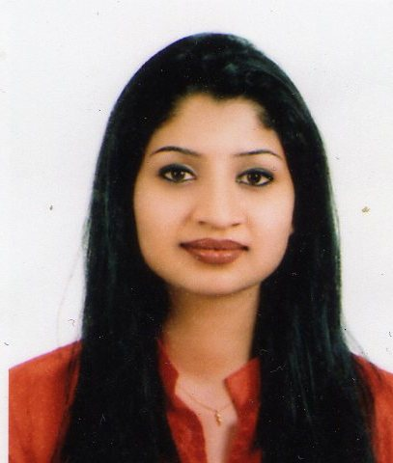 |  | Bindu Das  PHONE: +971 50 7858782  EMAIL: das.bindu@gmail.com  Customer Service, Marketing and Office Administration Professional
Profile  Customer Service professional with over 12 years of experience in customer care, client services and administration roles with professional organizations like Emirates, Dnata, Fly Dubai etc.  Personal details  Phone: +97150-7858782  Email: Das.bindu@gmail.com  Date of Birth: 25/4/1979  Nationality: Indian  Marital Status: Married  Visa Status: Spouse Visa  functional skills  Customer Care and Support  Client Services  Marketing  Office Administration  soft skills  Effective Communication  Listening Skills  Works well under pressure  Organization  Detail Oriented  Time Management  languages  English  Malayalam  Hindi  computer skills  MS Office  Internet  training  In-house Workshops in Customer  Service, Motivation, Communication  Introduction to Civil Aviation and  Airport Passenger Handing |  | WORK EXPERIENCE  Dnata, Dubai, UAE - Passenger Service and Resource Planning Co-Ordinator  Feb 2000 to Sep 2004  - Managed premium class counters and VIP terminals handling high profile passengers  - Managed manpower planning and allocations using RMS software  Emirates Airlines, Dubai, UAE - Customer service supervisor/Cabin Crew  Sept 2004–June 2010  - Supervised Special Services , First Class and Business Class lounges  - Managed VIP customers  - Managed mishandled passengers for service recovery  - Co-ordinated with Ministry of Health and Airport Medical center for  emergencies.  - Passenger care and safety briefing  Fly Dubai, Dubai, UAE – Leave Administrator  Dec 2010–Aug 2013  - Managed leave schedules of pilots and crew members  - Supported in daily roaster planning  - Briefed new recruits  Holistic Healing Center, Dubai, UAE – Marketing and Office Administrator  Oct 2013-Jan 2015  - Managed new clients by counselling and guidance.  - Supported in developing new workshops for the Center  - Managed all administrative activities of the center  Rhythm Yoga Center, Dubai, UAE – Marketing and Office Administrator  Dec 2016 – Sept 2017  - Lead marketing initiatives to boost sales  - Planned workshops and programs  - Managed customer queries and concerns  - Managed all office administrative work.  EDUCATION  - Master’s Degree in Alternate Medicine  - A level British Council, Dubai  key achievements  - Certificate of Appreciation awarded by HH Sheikh Ahmed Bin Saeed Al  Maktoum, Chairman Emirates Group for outstanding customer service  - Certificate of Appreciation from Emirates Airlines, Singapore Airlines, British  Airways and Saudi Airlines

