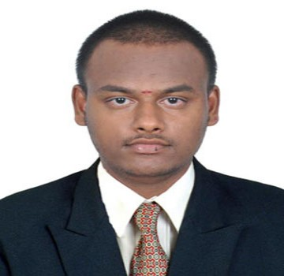**Aravinth Thangarasu**

B.E-Mechanical Engineer

Contact No : +971-524480801

Alquoz Industrial Area-2-Dubai.

Mail Id: [**aravinth26195@gmail.com**](mailto:aravinth26195@gmail.com)

**Career Objective**

To gain an Middle level position in an organization as Mechanical Engineer.Where I can contribute my knowledge and skills to organization and enhance my experience through continuous Learning and Teamwork.

**Professional Summary**

**Company :** RHS LOGISTICS-DWC-DUBAI

**Designation :** Store Keeper

**Experience : 24** Months (Aug 2018 to Till date).

**Responsibility**

* Lead & Maintain the Project
* Maintaining Inventory Count and Picking the Products from the Location.
* Place the Order in Sorting Items.
* Acting as an Store Keeper,Maintaining the store stock list both in ledger as well as computer.
* Pack,Stock,Organize and Rearrange the Products in Warehouse
* Organize and maintain records of inventories up to date
* Monitor and manage inventory control
* Manage and handle shipping, loading and unloading of products
* Handle delicate and sensitive products with utmost care
* Superior administration abilities
* Strong clerical and office management skills
* Excellent proficiency with MS Office application
* Assisted in performance of all administrative duties as assigned
* Sound written and oral communication skills

**India Experience**

* **ICICI BANK –INDIA-(JUNE 2016-JANUARY 2017)**

* **DESIGNATION- SALES OFFICER**

* Maintained relationships with our clients stores and customers
* Managed payments and accounts receivable processing online payments
* Conduct the campaign for achieving our target
* Report weekly or monthly business to our sales manager
* Co Ordinated Sales activities with marketing executive team
* Assisted customers with deposits withdrawals and opening new account

* **EXIM KNITS PRIVATE LIMITED-INDIA ( JANUARY 2017- JULY 2017)**
* **DESIGNATION – ADMIN ASSISTANT**
  + - * + Training and labour relations activities
        + Support and implement effective recommendations on the design and development of assigned areas
        + To perform on-going evaluations of the program effectiveness
        + Identify staff vacancies and report to human resource management
        + Management of office equipment
        + Maintaining a clean and enjoyable working environment
        + Handling external or internal communication or management systems
        + Managing clerical or other administrative staff
        + Organizing, arranging and coordinating meetings
        + Sorting and distributing incoming and outgoing post

* **PROPEL INDUSTRIES PVT LTD (AUGUST 2017- JULY 2018)**

**DEPARTMENT**  **: NEW PRODUCT DEVELOPEMENT**

**DESIGNATION : PRODUCTION ENGINEER**

**Scope of Work**

* Preparation of Project Schedule and Responsible for Creating and Expediting key project
* Sticking to the cycle time for the completion of the project
* Allocate the Work as per Daily Production Plan
* Did Inspection for Production stages & Making the Production Dimensional Report
* Solving problems in Process Drawing
* Monthly Raw material and consumable planning for project
* Making opportunities,Solutions for various problems in the stage of production
* Arranging the meetings to share Technically innovative ideas with various departments and regarding the Project
* Responsible for Outsourcing of accessories components-Vendor Side
* To Create the Production Plan Discuss with Design Team
* Responsible for Quality Aspects to complete the job as per QP,and PRC
* Need To be Check Welding Quality as Per WPS

**Additional Qualification**

* CNC
* AUTO CAD
* MS OFFICE

**Personal Information**

Name : Aravinth T

Father’s Name : Thangarasu A

Mother’s Name : Malar T

Age : 24 Years

Date of Birth : 17-05-1995

Blood Group : B+

Languages Known : Tamil,English,Malayalam,Hindi

**Declaration**

I Hereby declare that all the information mentioned above is true and complete to the best of my knowledge.

**Date :**  **Signature**

**Place :** Dubai (T Aravinth)