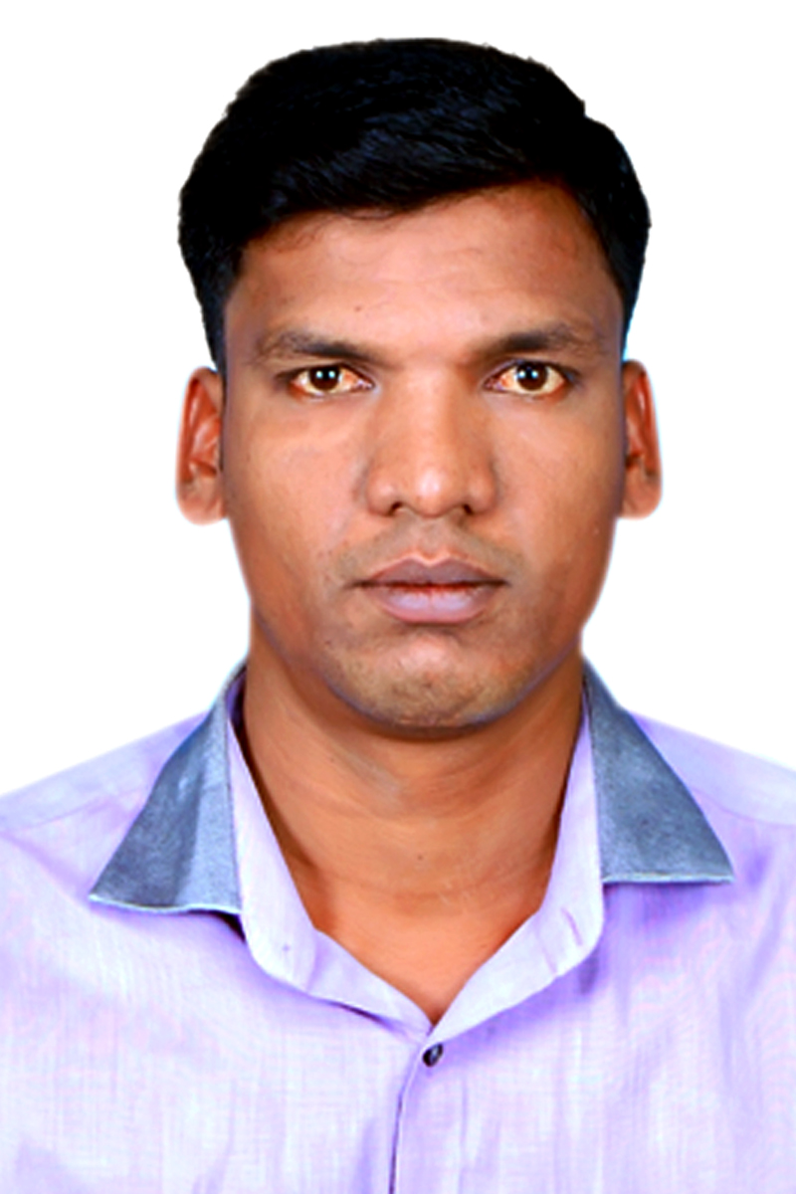

**KANNATHASAN. A**

No:52, KASI VISHWANATHAR

KOIL KUPPAM,

TIRUVOTTIYUR,

CHENNAI- 600 019.

Mobile:7338918716, 7708585045

Mail Id : akannathasan86@gmail.com

**CAREER OBJECTIVE**

**To obtain a position of responsibilities that utilizes my skills and experience nd keen to work in an environment where I can enrich my knowledge and my personal traits are:**

* **Motivation and willingness to learn new skills**
* **Possess good leadership qualities.**
* **Take initiative and work independently or part of a group**
* **Positive attitude**

**ACADEMIC QUALIFICATION**

|  |  |  |  |
| --- | --- | --- | --- |
| **Course Studied** | **Name of the Institution** | **Board/**  **University** | **Years of passing** |
| **B.A.,Economics** | **Pachaiyappa’s College of arts & Science, Chennai-30** | **Universsity of Madras** | **2006-2009** |
| **H.S.C** | **Government Higher**  **Secondary School,Chennai-57** | **State Board** | **2005-2006** |
| **S.S.L.C** | **Vellaiyanchettiar**  **Higher Secondary School,Chennai - 19** | **State Board** | **2003-2004** |
| **PCRSM** | **TEG international college in Singapore** | **Singapore** | **2019-2020** |
|  |  |  |  |

**COMPUTER SKILL/ TECHNICAL SKILLS**

* DCA (Diploma in Computer Application)

**EXPERIENCE**

* Worked as in wherehouse store keeper 4month in **Singapore**
* Worked as a Gmmco in Mechanical Fitter (1Year)
* Worked as a Aruna Generator in Mechanical Fitter ( 1Year)
* Worked as a Saravana Engineering Rigger for 6 years in
* Worked as a L&T port in Chennai store keeper 2year

**PERSONAL PROFILE**

Name : KANNATHASAN.A

Father’s Name : R. Anjappan

Date Of Birth : 16.06.1986

Gender : Male

Languages : English & Tamil

Nationality : Indian

Technical Qualification : Mechanical Fitter and Rigger ,**Store keeper**

**PASSPORT DETAILS**

Old Passport No : G4767913

Date of Issue : 31/08/2007

Date of Expiry : 30/08/2017

New Passport No : R3775012

Date of Issue : 11/09/2017

Date of Expiry : 10/09/2027

**DECLARATION**

I hereby declare that the details furnished above are true to the best of my knowledge and belief.

Place: Chennai Date:

**(**KANNATHASAN.A **)**