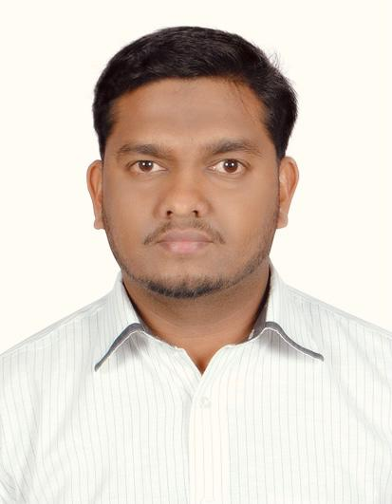

# PROFILE

RAYEES Elambilatt keloth

**Mobile :** +971 52 53 44 905

**Email :** emblrayees[@gmail.com](mailto:shammasch95@gmail.com)

**DOB :** 25-05-1979

**DUBAI -**UAE

**UAE Driving License (manual)**

**Visit Visa valid up to 30-11-2021**

**Office assistant cum Driver (personal Driver)**

**UAE Driving License No:** 2146584

An enthusiastic and dedicated individual with remarkable background and over 13 years’ experience in banking customer hospitality and filing. Has positive attitude towards life, work and learning. Aspiring to be part of a challenging work environment to substantially build on my professional career.

# EDUCATION

***Basic Computer Course***

*Galaxy Computer Education & Training Institute (Abu Dhabi)*

## Senior Secondary Education – Commerce, Grade 12

*Prethibha College, Kannur (Kerala board)*

## Secondary Education - Grade 10

*Chembilod high school, Kannur (Kerala board)*

# WORK EXPERIENCE

### ADIB – Dubai, UAE

*November 2007 to November 2020,13years* ***(Office Assistant cum Driver)***

* Organize and schedule appointments for team leaders.
* Preparing documents, responding to E-mails.
* Organizing and accurately maintaining filing system of confidential information.
* Screening phone calls, emails, letters and personal visits.
* Follow up with customer regarding banking documents
* Checking and replaying office documents.

# LANGUAGES

* English
* Hindi
* Arabic
* Tamil and Kannada
* Malayalam

# PERSONAL DETAILS

Gender : Male

Passport no : M1485591

Marital Status: Married

Nationality : Indian