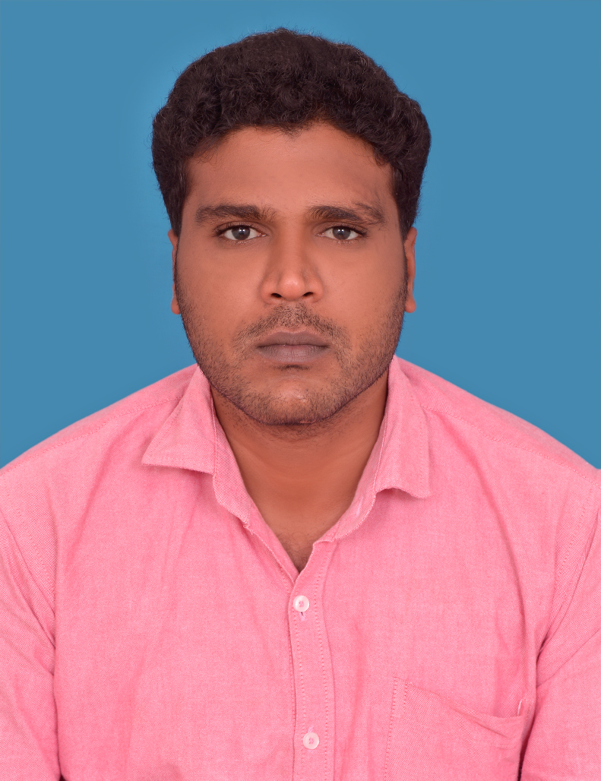
Mohamed Meeran Mohadeen
MEP SITE ENGINEER
E-Mail: mohamedmeeran24@gmail.com
India: +916374428840,+919486563548

PRofile
A Professional having 10 Years experience in MEP Engineering Quantity Takeoff (Mechanical, Electrical,Plumbing), Preparation of Purchase Orders and Identification of Change Orders ,Site Execute, High Rise Buildings, Residential Building and Commercial Buildings.
FOCUS
To get challenging job in an organization where I can work towards the growth, Improvement and profit of the company and to produce good quality as well as more productivity.
Achivements
- B.Tech Mechanical Engineering .
Computer Cognizance
- Software’s : AutoCAD, MS Office.
experience
- Name of the Company : QS Square Private Ltd
Chennai,India.
Designation : MEP ENGINEER
Working Experience : One Year and One Month
Duration : From September 2019 to Still at Present
Job Summary:
- Preparation and summaries of all measured works
- Quantity Take Off
- Variation Reports for clients changes in upcoming drawings,
- Reconciliation of materials and works executed during the month
- Preparation of Monthly Commercial reports in conjunction with PM and site team
- Co-ordinate with all company departments as required for the execution of the Project.
Projects Worked:
- G+4 (Residential),Sholinganallur, Chennai,India
- G+13(Residential-four Towers) ,Anna Nagar,Chennai,India.

2) Name of the Company : Albanna Electromechanical L.L.C
Dubai,United Arab Emirates
Designation : MEP SITE Engineer.(Plumbing&Electrical)
Working Experience : Four Years and Two Months.
Duration : From May 2015 to July 2019
Job Summary:
- Preparation of daily report and manpower allocation
- Performed Drainage Low level and High level ,Shaft vertical Riser piping.
- Performed Water supply PPR ,High Pressure piping.
- Performed Water Tank, Transfer and Booster pump installation with unit piping.
- Experience working with various pipe materials and fittings
- Analyzed drainage and water supply system of constructed buildings
- DB and SMDB Installation.
- Cable Glanding & Termination for SMDB and LV Panel
- Cable Tray route making as per site condition.
- Electrical sub meter and water sub meter arrangement work as per DEWA.
- Supervised and evaluated performance of team members
- Testing Commissioning work.
- Manpower handling &job assignment
- Coordinated with contractors on project
- Responsible for the site inspection
- Supervised and evaluated performance of team members
- Reporting to MEP Manager.
Projects Worked:
- Oxford-2 Residential Building (G+P+5+R),JVC,Dubai.
- Gul Mohamed Residential Building (G+P+7+R) ,International city,Dubai.
- Oxford-1 Resitential Building (G+P+4+R),JVC,Dubai.
- Crystal Residential Building (G+P+5+R),JVC,Dubai.
- J10 Tower Residential Building (B+G+8+Gym+R),A lsafouq,Dubai.
- J5 Tower Residential Building (G+5+Gym+R),Al safouq,Dubai.

3) Name of the Company : DJR Construction , Tirunelveli,India.
Designation : Mechanical Engineer.(Plumbing)
Working Experience : 10 Months
Duration : From July 2014 to May 2015

Job Summary:
- Performed Drainage Low level and High level ,Shaft vertical Riser piping.
- Performed Water supply PPR ,High Pressure piping.
- Performed water tank installation .
- Installs and repairs plumbing fixtures, sinks, water closets, bathtubs, water heaters, Garbage disposal units, dishwashers and Bathroom accessories.
- Proven ability to maintain records and organize daily activity reports
- Experience working with various pipe materials and fittings
- Analyzed drainage and water supply system of constructed buildings
- Inspected all materials associated with plumbing such as pipe
Project Worked.
- G+P+4 Residential Building,KTC Nagar,Tirunelveli,India.

4) Name of the Company : Fawzi Saleh Al Najrani Est
Najran,Kingdom of Saudi Arabia.
Designation : Junior- Mechanical Engineer.
Working Experience : One Year and Three Months
Duration : From March 2013 to June 2014
Job Summary:
- Manpower handling &job assignment
- Proven ability to maintain records and organize daily activity report
- Coordinated with contractors on project
- Responsible for the site inspection
- Prepare Material Quantity take offs from Approved drawings and as per site condition
- Supervised and evaluated performance of team members
- Reporting to MEP Manager.
Project Worked.
- Galaxy of Schools,Najran,Saudi Arabia.

5) Name of the Company : R.P.P. Construction Erode,India.
Designation : Site Supervisor
Working Experience : Two Years and Eleven Months
Duration : From April 2010 to March 2013

Job Summary:
- Supervised and evaluated performance of team members.
- Coordinate to Sub contractor
- Repoting to Senior Engineer
- Perform to all MEP Works.
- Manpower handling &job assignment
- Testing commissioning work
Project Worked.
- Commercial &Residential Building (G+1+R),Erode.India.
- Commercial & Residential Building (G+2+R),Erode.India.
Academic Chronicle
- B.Tech Mechanical Engineering
Rajasthan Vidyapeeth University ,Nagercoil,Tamilnadu ,India January,2015

- Diploma in Mechanical Engineering
The Indian Polytechnic College, Vadakkangulam, Tirunelveli,India. April,2010
personal information
Name : M.Mohamed Meeran Mohadeen.
Father’s name : K.M.Mohamed Iqbal
Date of Birth : 12 June 1990
Home Address : 161,Middle Street, Tirunelveli (Dist), Tamil Nadu (State), India
Qualification : B.Tech. (Mechanical Engineer.)
Religion : Islam
Nationality : Indian
Marital Status : Married
Language Known : English, Hindi, &Tamil.
Driving Licence : 3715157(A/G Light Vehicle),Dubai

PASSPORT DETAIL’S
Passport No. : U4805444
Date of Issue : 19-10-2020 ; Date of Expiry : 18-10-2030

DECLARATION
I do hereby declare that all the above-furnished details are genuine to the best of my
Knowledge.

Station: Chennai , India Yours Sincerely,
Date : MOHAMED MEERAN MOHADEEN

