**RESUME**

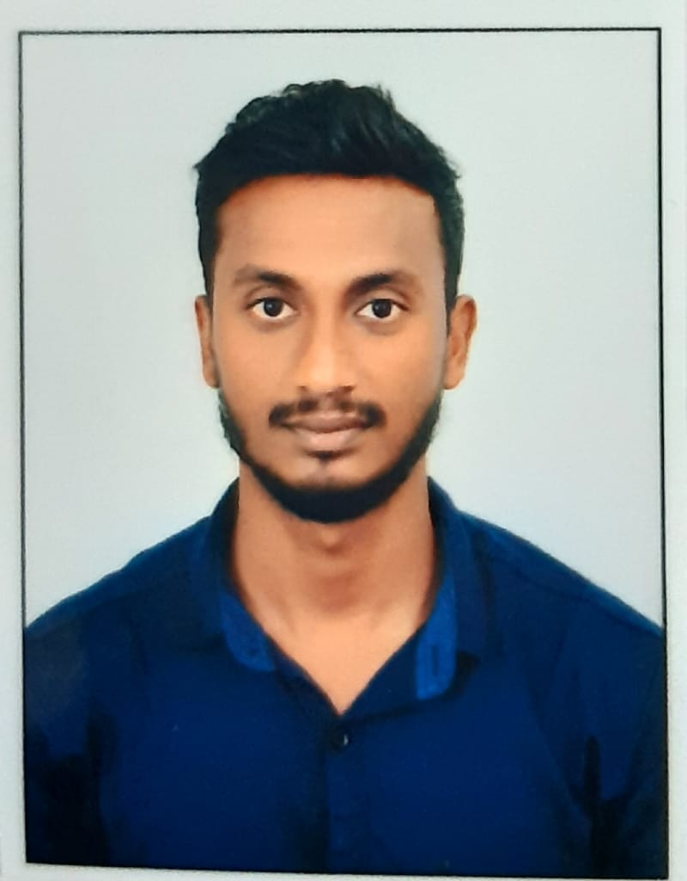

|  |  |  |
| --- | --- | --- |
| **Name** | **:** | **MOHAMMAD YAKUB KHAN** |
| **Date of birth** | **:** | **06/09/1997** |
| **Phone** | **:** | **90000915659** |
| **Email** | **:** | Yakubkhan9711@gmail.com |

CAREER OBJECTIVE

“To be a part of an esteemed organization, to understand the concept and requirement of given task and implementing the suitable methodology to complete it with creative mind, dedication and confidence in the given time span for the benefit of the organization as well as my-self.”

EDUCATION

|  |  |  |  |
| --- | --- | --- | --- |
| **Year** | **Course Studied** | **Name of the Institution / University** | **Major Subjects Studied** |
| 2019-2020 | PGD-IEM | BUREAU VERITAS | Quality Management,  Non-Destructive Testing Fire and Safety, Power Plant Erection, SIX sigma, Auditing, Design, |
| 2015-2019 | B.TECH | Nimra institute of science And Technology | Mechanical |
| 2013-2015 | Intermediate | Andhra Loyola College, Vijayawada | Maths,Physics,Chemistry |
| 2013 | S.S.C (10th) | Ravindra bharathi public school | English, Hindi, Telugu, Science, Maths, Social |

CERTIFICACATION IF ANY

* Completed training and certified according to **SNT-TC-1A standard** for **Non-destructive testing - LPT, MPT, UT, RT, RTFI, VT (ASNT, level-2).**
* Completed certification course on **Power plant erection.**
* Completed certification course on **Fire and Safety.**
* Completed certification course on **Quality Assurance and Quality Control.**
* Completed certification course on **CATIA and SOLIDWORKS.**

INDUSTRIAL VISITS

* Visited **NTTPS** on working of **Quality control & Quality assurance.**
* Visited **Bhadradri Thermal Power Plant** basis of **boiler erection.**
* Visited **Municipal corporation Vijayawada** on working of **roof top100kv Solar PV system.**

ACADEMIC PROJECTS

* Project work done on LOCO MOTIVE DIESEL SHED is
* (INSTALLATION AND DISMANTLING OF WHEELBASE OF LHB COACHES)

ACHIEVEMENTS (ACADEMIC & PROFESSIONAL)

* Attended a one day work shop on “ENTREPRENERSHIP DEVELOPMENT”

on 10-08-2018.

Participated in many events and quiz,Paper presentation and poster presentation.

IT PROFICIENCY

* MS Office (Word, Excel, Power point)
* AUTO CADD basics

EXTRA CURRICULAR ACTIVITIES

* Participated in college and school level debate and essay competition and received applauds.
* Event organizer in all school and college annual day functions and other technical events.
* Participated in project expo conducted on various colleges.

PERSONAL DETAIL

|  |  |  |
| --- | --- | --- |
| • | Father Name | Mohammad Asudulla khan |
| • | Date of Birth | 06-sep-1997 |
| • | Gender | Male |
| • | Nationality | India |
| • | Marital Status | Un Married |
| • | Language Known | English, Telugu,urdu. |
| • | Permanent Address | 74-31-12,Vijayawada,Krishna,Ap. |

DECLARATION

I hereby declare that the above particulars furnished by me are true to the best of my knowledge and belief. And i'm willing to relocate.

PLACE : VIJAYAWADA (**Mohammad yakub khan)**

DATE : Signature