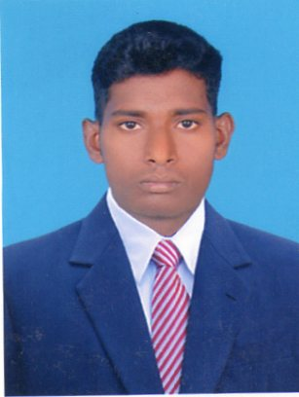

**RAJA.M**

Mobile : +919789476031

Email Id : alvin.raja46@gmail.com

**Chef de Partie:**

Experienced in food production in Indian restaurants as well as running hot and cold kitchen operations.

**CAREER OBJECTIVE:**

To continue to grow in leadership and knowledge, excel in the field of F&B Production. Interact and share with team members and colleagues and utilize my current job knowledge to develop world class solutions to real world challenges that provide me an opportunity to deliver my enthusiastic skills in a quality where I will perform and facilitate achievements to the organization.

**PROFESSIONAL EXPERIENCE:**

* **Commis – I in Lu Lu Group, Dubai.**

From January 2018 till Present

* **Commis – II in Sanhranti Restaurant, Singapore.**

From August 2014 till Dec 2015

* **Commis – II in Hotel Casino Wellington Island, Cochin, India**

From June 2009 till March 2012

* **Commis – III in Hotel Piccadilly, India.**

From Oct 2007 till March 2008

**Education:**

* **Diploma in Hotel Management & Catering Technology - 2009**
  + - Institute of Hotel management, India
* **B.Sc., Hospitality & Hotel Administration – 2009** 
  + - Tamilnadu Open University, India

**KEY SKILLS:**

* Strong in presentation, Analytical & Quantitative skills
* Controlling food cost
* Innovation & Creating new recipes.
* Ability to understand how business results ultimately tie to F&B Production performance
* Experience in Live Counter in Buffet.
* Regular interaction with the guest in terms of their preferences and choices
* Prepare and present buffet food in pans and garnish them and replenish them at time to time.
* Maintaining HACCPstandards and Assisting chef in all day to day operation
* Specialized in Working with Tandoori cooking and Indian food preparation
* Working in Pass to make sure in smooth flow of operation
* Making new Menu
* Taking feedback from the Guest about the food.
* Maintaining highest standards of cleanliness and hygiene in the display kitchen as well as in see through chillers.
* Good with guest in giving the special food orders.
* Preparing ahead for the special events like New Year and Christmas etc.

**PERSONAL PROFILE:**

Mothers Name : Selvarani

Date Of Birth : 4-06-1988

Language : English,Hindi,Tamil & Malayalam.

Passport No : G2099188

**REFFERENCE:**

**Chef Muthu Kumaravel**

CDP, Mirdif City Center,

Carluccio’s.

+971-552045352