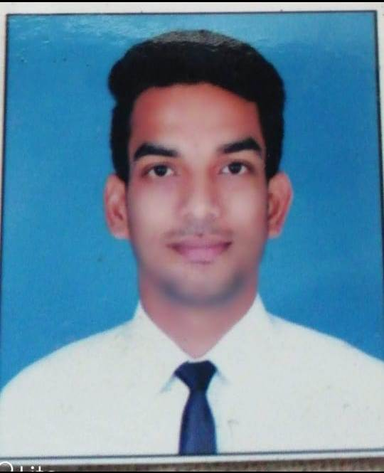

Rohit Rajput

**Address :**79 Aadinath nagar behind

Electronic complex, Indore (M.P)  
,India

**Best time of day to contact :** Anytime

**Date of Birth :**10th July 1996

**Place of Birth :**Indore

, India

**Gender :**Male

### Country of Citizenship :India

### Country of Residence :India

**Field of Training Desired :**Service

**Date available to start work :** As soon as possible.

**Contact** :+918770145927, +918518061428

E-mail id : rjrohitrajput@gmail.com

##### 

##### University/School Name : Malwa Institute of Hotel Management

**Location :** Indore,India

**Graduation/Expected graduation date :**Oct, 2019

**Field of Study :**B.B.A Hotel Management

**University/School contact name :**Malwa Institute of Hotel Management

**University/School contact tel :** +91-08516888823

**University/School contact email :** mihm1011@gmail.com

**University/school website :**www.mihmindia.in

##### Classes Taken at School/University Relevant to Desired Training:

* Food and Beverages Service Operations
* Service of Beverages –Laboratory
* Front Office
* House Keeping
* Laundry

##### 

##### Company Name : The Leela Goa

**Company contact name :** Miss. Sheetal Bale

**Company contact tel :** +91 (832)6621234

**Company website :** http://theleela.com

**Position :** Trainee

**Duration :** From Feb 2016 to Apr 2016

**Location :** Goa, India

**Total Number of Months :** 2 Months

**Tasks/Responsibilities:**

* Work according to the instructions of supervisor in Housekeeping
* House Keeping Pantry Section
* Cover setup of restaurant and Buffet setup for Lunch and Dinner in Food and Beverage
* Wiping cutleries & crockeries
* Work as a Business centre in Front Office

##### Company Name : Lean Indulgence

**Company contact name :** Mr. Gulshan Joshi

**Company contact tel :** +91 0731 655 0666

**Position :** JR GSA

**Duration :** 01May 2016 to 31Dec 2016

**Location :** Indore

**Total Number of Months :** 8 Months

**Tasks/Responsibilities:**

##### Company Name : Park Plaza

**Company contact name :** Miss. Sumnta Chakraborty

**Company contact tel :** +91

**Position :** Industrial Training

**Duration :** 10 Jan 2017 to 10May 2017

**Location :** Bengaluru

**Total Number of Months :** 4 Months

**Tasks/Responsibilities:**

* Breakfast Setup
* Cover setup of restaurant and Buffet setup for Lunch and Dinner in Food and Beverage
* I taught coffee making, and learning different type of services

##### Company Name : For u Café Lounge (FREITO)

**Company contact name :** Mr. Jeet Rochlani

**Company contact tel :** +91 9303030269

**Position :** As captain.

**Duration :** 01 June 2017 to 01 Aug 2018

**Location :** Indore

**Total Number of Months :** 1Year 2 Months

**Tasks/Responsibilities:**

* Supervising restaurant functions.
* Communication between kitchen and waiter staff.
* Making the shifting and duty roaster staff.
* Have to check personal hygiene, K.O.T and B.O.T, Punctuality and performance of service.

##### Company Name : 22° North Café and Restaurant (Woodapple F&B Pvt. Ltd.)

**Company contact name :** Mr. Abhinav Johari.

**Company contact tel :** +91 911178965

**Position :** As Assistant Manager.

**Duration :** 01 Oct 2018 to till date.

**Location :** Indore

**Total Number of Months :** 2Year 2 Months

**Tasks/Responsibilities:**

* Supervising restaurant functions and service staff and reporting to Manager.
* Provides feedback and coaching to the Team regularly.
* Check the quality of deliveries of fresh food and baked goods.
* Is capable of handling irate customers with a friendly.
* Handling cash counter, register, credit card, and cash register.

##### 

##### Company Name : Dhon manik sky view Café and Restaurant

**Company contact name : Hamid Afeef**

**Company contact tel :** +960 7776341

**Position :** As A Supervisor

**Duration :** 10 jan 2021 to 15 june

**Location : Malé Maldives**

**Total Number of Months :** 5 Month



**Languages & Level :**English- Fluent, Hindi- Fluent

**Computer Skills :**MS OFFICE

**Achievements/Certifications :**Certificate of participation in 3 Days volunteeringin International Conference Summit in Indore

Certificate of Global Investor Summit in Indore (2016) in F&B service



**Interacting with people of different cultures, exploring new place and people,**