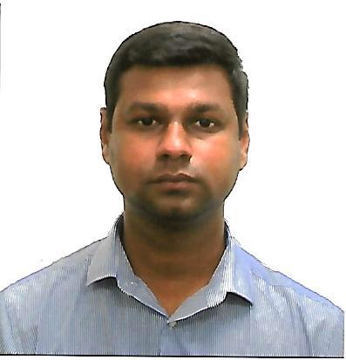
SAMEER AHMED
Al Muraqqabat Rd, Deira - Dubai.
Email : a.sameerahmed@gmail.com
Contact : +971 52 744 0651

OBJECTIVE
To obtain a long-term career with an organization which has a strong background that provides good opportunity for enhancement of professional and personal status.

WORK EXPERIENCE

UNITED ARAB EMIRATES
Admin Cum Account Assistant
ABDA Cargo Services DMCC, Dubai, UAE (April 2014 - Present)
- Work Experience as an Accounting Assistant or Accounting Clerk.
- Knowledge of Basic Bookkeeping Procedure.
- Hands-On Experience with MS Excel and Accounting Software (Tally ERP & Zoho Book).
- Organization Skills Ability to Handle Sensitive.
- Online Bank Transactions.
- Immigration Related Work.
- Other Office Related Work.
- Registration of Vehicle.
- Sound Knowledge of Labor Law.
- Collections.

Assistant to Public Relations Officer (PRO)
Al Liali Jewellery LLC, Dubai, UAE (January 2014 – April 2014)
- Bank Transactions.
- Immigration Related Work.
- Registration of Vehicles.
- Sound Knowledge of Labor Law.
- Collections.

INDIA
Air Ticketing and Reservation Clerk
Akbar Travels, Pondicherry, Tamilnadu, India (2012 – 2013)
- Booking Air Tickets and Advise Customers.
- Manage Contact Lists and Customer Spreadsheet.
- Make Travel Arrangements to the Staffs for Office Trip.
- Prepare and Sent Out the E-mail Newsletter.
- Prepare Meeting Materials.
- Handle Client Inquiries by Phone or E-mail.
- Other Office Related Works.

EDUCATION
Bachelor of Business Administration (2010 – 2012)
Tamil Nadu Open University, Thanjavur, Tamil Nadu, India

Diploma in Advanced Airlines and Travel Management Programme (2010)
Institute of Airlines and Travel Agencies, Tiruchirappalli, Tamil Nadu, India

Higher Secondary School (2008 – 2009)
Fatima Mariam Higher Secondary School, Madukkur, Tamilnadu, India

SYSTEM EXPOSURE
- Tally ERP.
- Zoho Book.
- MS Office.

PERSONAL STRENGTH
- Highly motivated and eager to learn new things.
- Effective time management.
- Strong motivational and leadership skills.
- Ability to work as individual as well as in group.

PERSONAL DETAILS

Date of Birth : 10TH December 1988
Gender : Male
Nationality : Indian
Languages Known : English, Tamil, Hindi, Malayalam
Passport No : U2972768
Driving License : Light Motor Vehicle (Manual)

DECLERATION

I hereby declare that all the information and particulars mentioned above are true to the best of my knowledge and belief.

