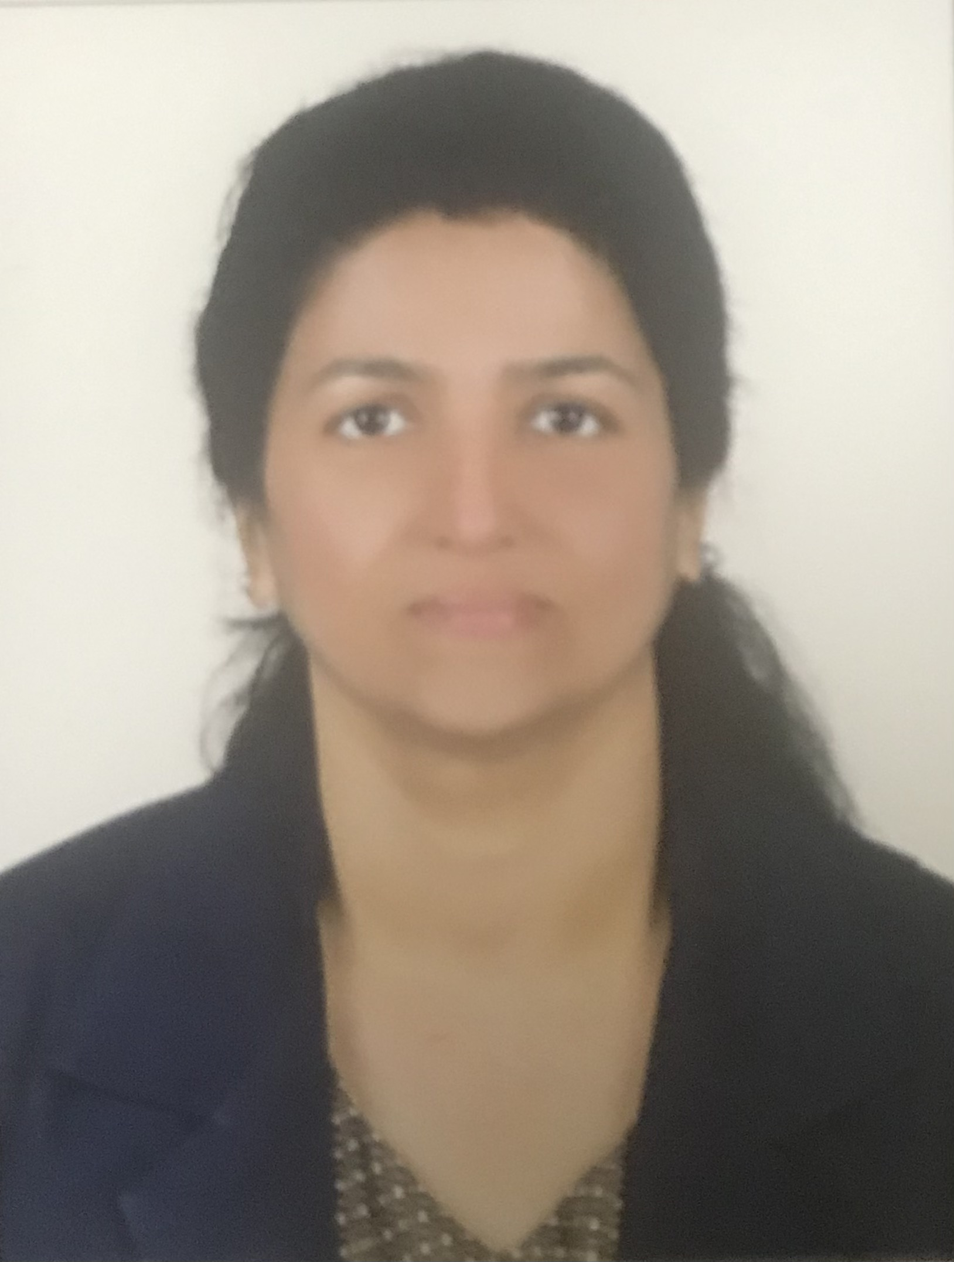
Suseela Shiju
Landline: 06-5485531
Mobile: 00971-50-3028971
Email: sonushiju@gmail.com

Objective
To offer my excellent administrative and secretarial skills for the betterment of the organization. By being a part of the team, can apply my extensive background in team building-motivation, management as well as communication skills.

Profile
Excellent computer and typewriting skills with knowledge in MS-Office tools including outlook email, BABS, CRS, Mainframe system. A strong team player, with extensive experience in day to day administration, maintaining online files, keep records up-to date, follow-up with vendors and customers. Been the highest productive staff by maintaining error free work. Initiated Process Improvement and was awarded the best disciplined employee as well as the highest in Reseating, Group Seating, Medical Seating and Bassinet Seating.

Personal Details:
Date of Birth: 12th January 1973
Visa status: Husband’s Visa

Work Experience

May 2012- December 2012 (Temporary Contract): Asst. HR Manager - ULO Systems LLC
Responsibilities:
- Monitor, maintain, update personnel files such as offshore certificates, CV, personnel information, visas, labour cards, driving licence, passport, emirates ID, seaman’s book.
- Work with other divisional supervisors to recognize the requirements of training for all staff, source companies and arrange for training and maintain records as per ISO standards.
- Control all movements of offshore personnel including visa formalities, flight bookings and hotel accommodation.
- Allocate personnel for various projects based on availability, status of certs/ visa and number of offshore days.
- Maintain booking of flights for onshore based personnel.
- Source, advice and assist on application forms for visas for other countries other than UAE.
- Assist Operations Manager in providing supporting documentation to the client for the offshore personnel.

July 2006 – June 2007: Receptionist/Secretary/Purchase Assistant - Irrigation Trade Middle East LLC, Dubai
Responsibilities:
- Assist in various day to day office activities such as Payroll and leave scheduling, preparing enquiries, issue Purchase Orders, preparing monthly reports as required.
- Handled purchasing of office stationery, office equipment etc.
- Handed day to day correspondence of various suppliers.

January 2006- June 2006: Operations Assistant/Receptionist - Shepherd International LLC, Dubai
Responsibilities:
- Worked as Operations Assistant cum Receptionist in a leading Shipping and Freight Forwarding Company for a period of 6 months

September 2001 – August 2005: Senior Customer Service Associate / Customer Service Associate - WNS Global Services Private Limited, Pune, India
Responsibilities:
- As a Senior Customer Service Associate worked in the KLM Royal Dutch Airlines department and was responsible to, validate all the booking for the sectors are done as per the KLM procedure.
- Prepare Special Service Request on behalf of clients and authorize the same.
- Prepare Roster, Weekly and Monthly Reports.
- Plan for manpower requirement based on shifts and as per volume received
- Delegate work, motivate and shadow staff as and when required.
- As a Customer Service Associate worked in the British Airways department and handled Multifunctional between processes, allocation of seats to passengers prior to check-in.
- Prepared various reports.
- Inter-team and department communications about the day to day system
- Worked for BA Fuel Planning Department to enter Techlog Data in TIFF system
- Worked for BA Engineering Wide System (BA EWS) Department for “Engine Records System Data Transformation Procedure” Project to clean data for SAP as BA was changing Main Frame to SAP.
- Worked for Human Resources Department for the Recruitment Staff process

6 months in 2001: Assistant Secretary and Hostel Assistant - Y.W.C.A
6 months in 1999: Secretary and Receptionist - Eximlink International Sharjah, U.A.E

Education

- Degree in Bachelor of Arts (Sociology) from Mahatma Gandhi University, Kerala, India
- Diploma in International Airlines Travel & Tourism Management (DIATM), Pune, India
- Advanced Diploma in Network Centered Computing (ANC), Pune, India

Additional details can be provided upon request.

